Slide 1 - It's Just Grammar!
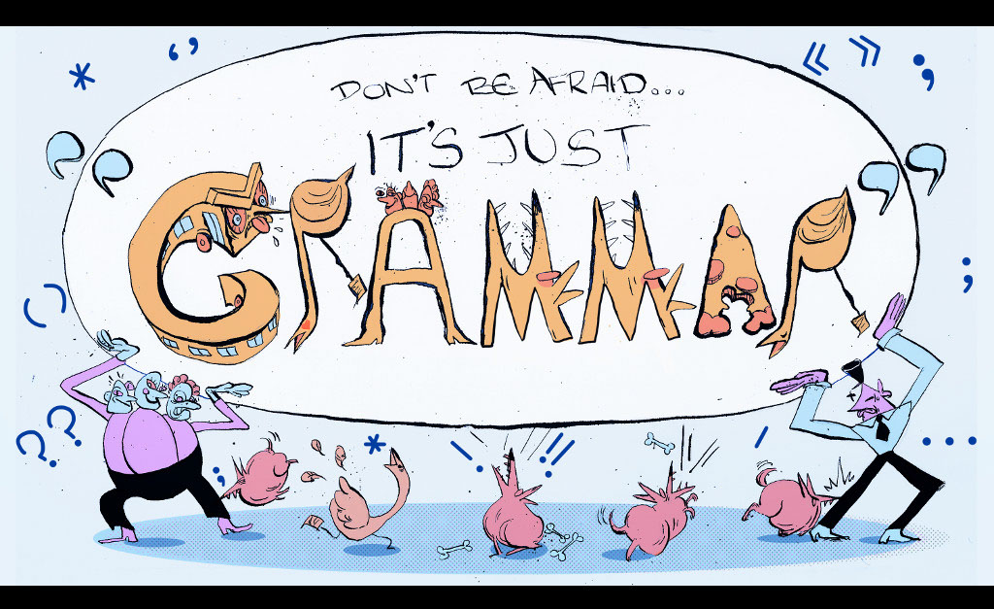
Slide notes
Text Captions

Don’t Be Afraid… It’s Just “Grammar”
Slide 2 - Topic 5: Commonly Confused Words
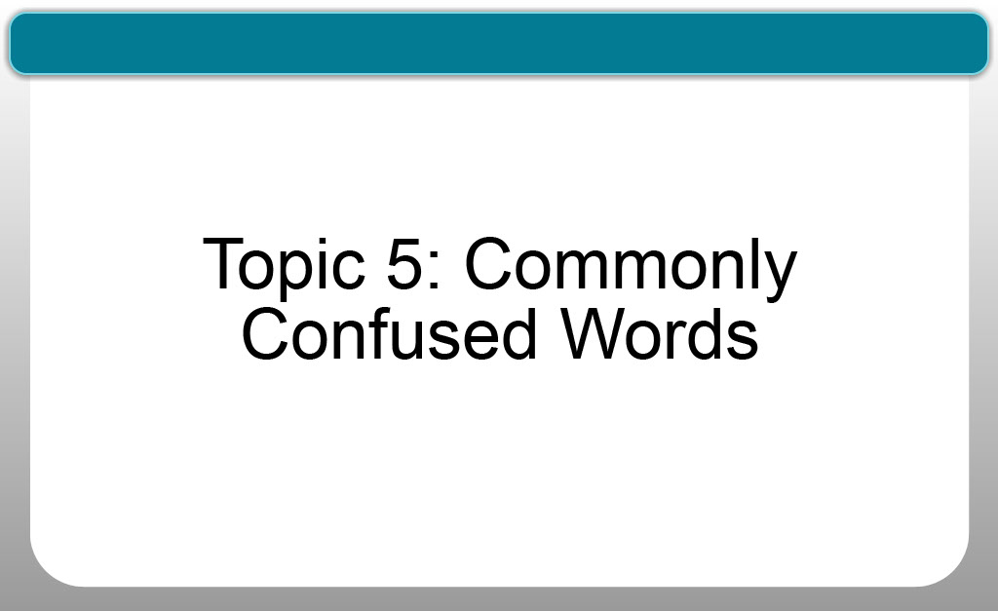
Slide notes
Text Captions

Topic 5: Commonly Confused Words

Slide 3 - Topic Navigation
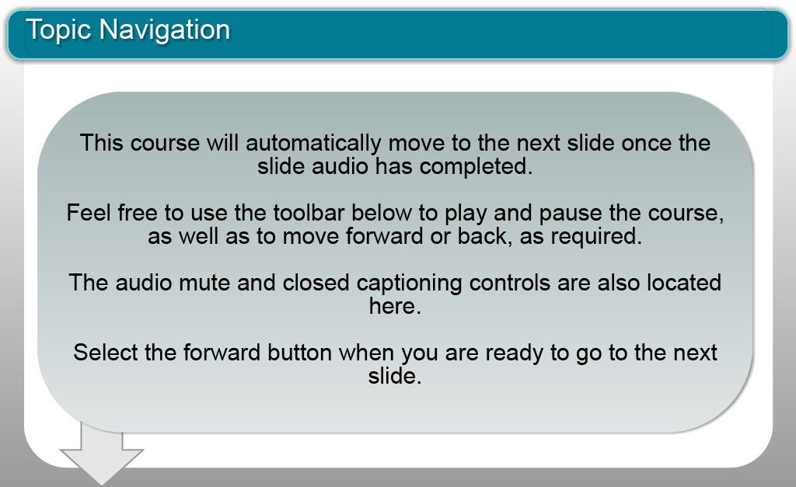
Slide notes
Text Captions

Topic Navigation

This course will automatically move to the next slide once the slide audio has completed.

Feel free to use the toolbar below to play and pause the course, as well as to move forward or back, as required.

The audio mute and closed captioning controls are also located here.
Select the forward button when you are ready to go to the next slide.

Slide 4 - Introduction
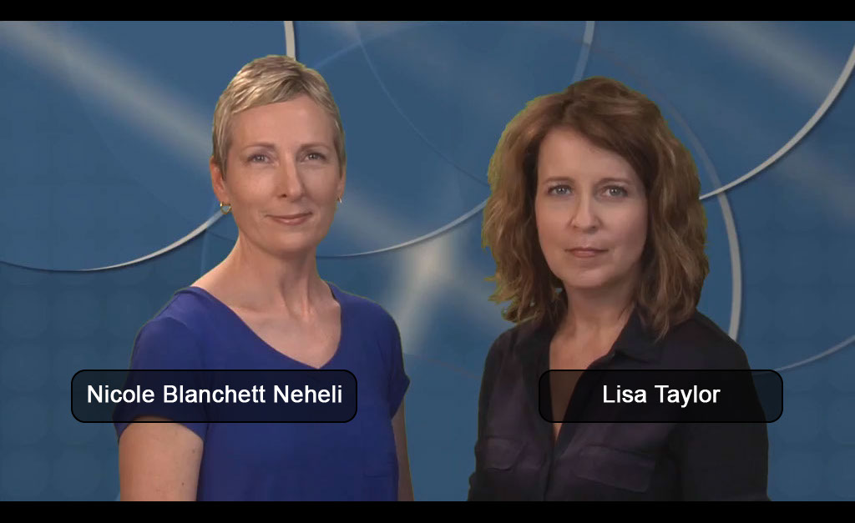
Slide notes
Text Captions
LISA: I'm Lisa Taylor.
NICOLE: And I'm Nicole Blanchett Neheli. We're two journalism professors who both see our students struggle with grammar. So, we created a series of videos to help clarify some of the most confusing grammatical rules.
LISA: In this video, we’ll look at commonly confused words. We’ll explain how each of these words is used, and give you tips to help use the words correctly in your writing.
NICOLE: Clarity is everything when it comes to writing. Unfortunately, English can make it tough, because there are many, many words that sound similar, but have different meanings.
LISA: We can’t take you through every one of them, because there are just so many, but we hope the examples we cover in this video will help you think carefully about whether you’re saying
NICOLE: If you’re interested — and we KNOW you will be — you can find lists of commonly confused words online or in just about any grammar or writing book.
Slide 5 - They're
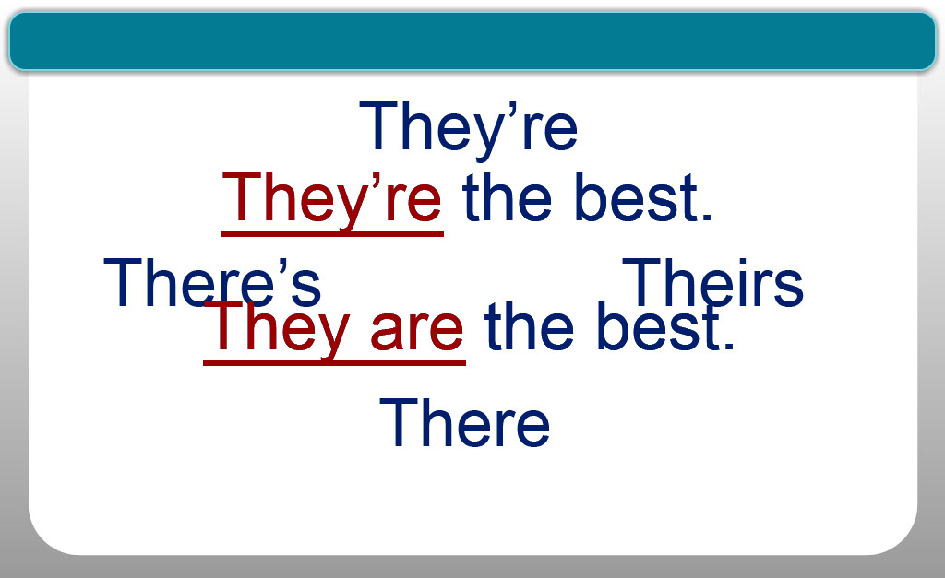
Slide notes
LISA: They’re, there, there’s, theirs...
argh...a source of endless confusion,
so let’s take them one at a time.
First, the easiest one:
T-H-E-Y-apostrophe-R-E.
It’s just a matter of understanding the purpose of the apostrophe,
then you should be able to get this right.
Any time you use “they’re,” you should be able to remove it
and replace it with “they are”.
If it doesn’t make sense, you’ve used the wrong “they’re.”
Text Captions

They’re

There

Theirs

There’s

They’re the best.

They are the best.

They’re the best.

They are the best.

Slide 6 - There
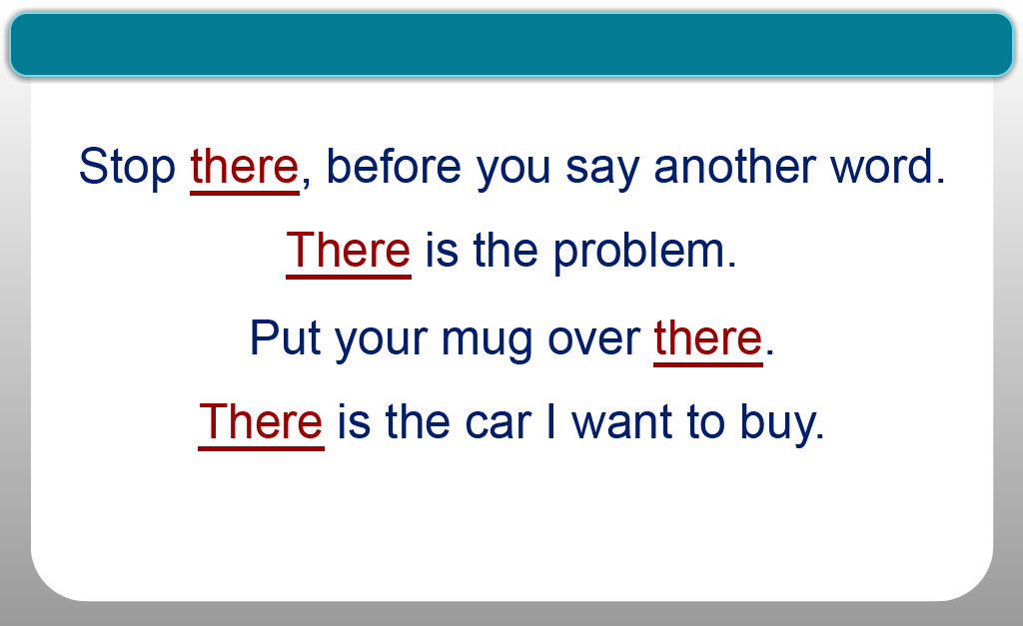
Slide notes
NICOLE: Next: T-H-E-R-E is a word with several meanings.
It can refer to a point in time, as in,
“Stop there, before you say another word,”
or in reference to a matter, as in,
“There is the problem.”
T-H-E-R-E also indicates location, as in,
“Put your mug over there,”
or “There is the car I want to buy”.
Want an easy trick to remember this?
“Here and there” is a common phrase —
so common, in fact, that
“HERE” is actually embedded in the word THERE.
Text Captions

There is the car I want to buy.

Put your mug over there.

There is the problem.

Stop there, before you say another word.

Slide 7 - There's
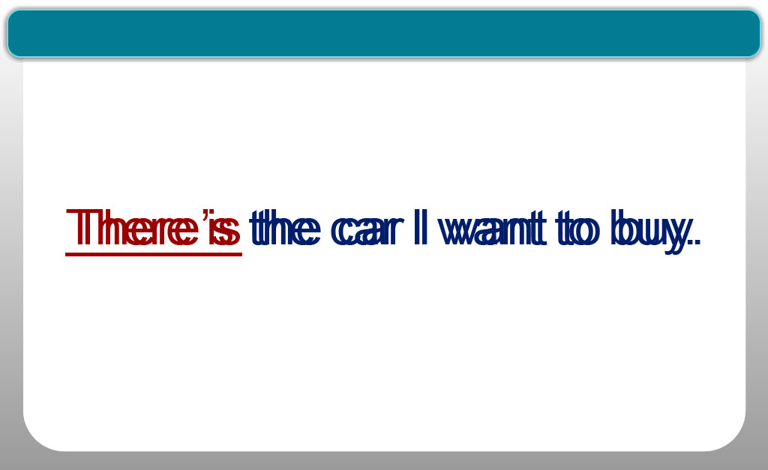
Slide notes
So, what happens we add an apostrophe-S to T-H-E-R-E?
It reflects the way we usually speak —
instead of saying “There is the car I want to buy,”
most people would say “There’s the car I want to buy”;
T-H-E-R-E-apostrophe-S is simply a contraction of “there is.”
Text Captions

There is the car I want to buy.

There’s the car I want to buy.

Slide 8 - Their
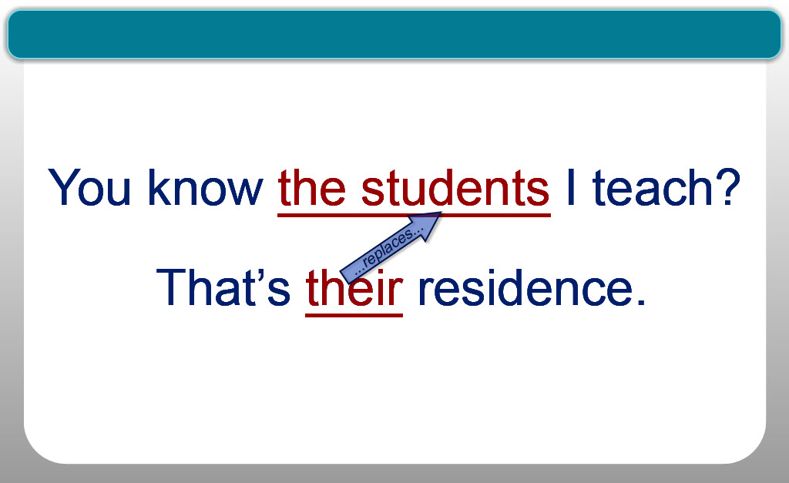
Slide notes
LISA: Finally: T-H-E-I-R is a plural possessive pronoun;
I know that sounds complicated,
so let’s look at a few example.
“You know the students I teach? That’s their residence.”
In this instance, T-H-E-I-R is a pronoun.
I’ve used “their” to replace “the students’”
when referring to the residence they live in.
So, in this case, T-H-E-I-R is a simple substitute for “the students.”
Text Captions

You know the students I teach?

That’s their residence.

You know the students I teach?

That’s their residence.

You know the students I teach?

That’s their residence.

...replaces...

Slide 9 - Summary
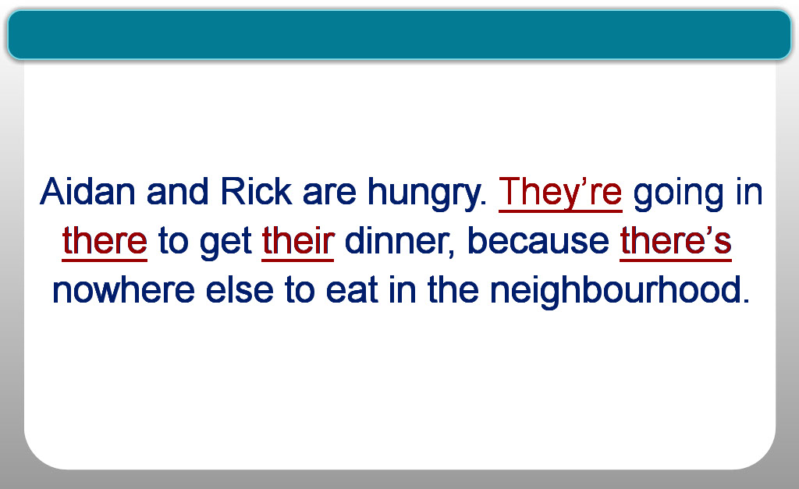
Slide notes
Let’s look at all these “theres” in action.
“Aidan and Rick are hungry.
They’re going in there to get their dinner, because
because there’s nowhere else to eat in the neighbourhood.”
The first “they’re” is a contraction;
it means the same thing as “they are”.
Next, we have T-H-E-R-E — it refers to the place,
in this case the restaurant.
T-H-E-I-R is the possessive pronoun that replaces “Aidan and Rick”
and indicates whose dinner we’re talking about.
Finally, T-H-E-R-E-apostrophe-S is simply an informal way
to say “there is”. The comma tells us that it’s a contraction.
Text Captions

Slide 10 - Accept vs. Except
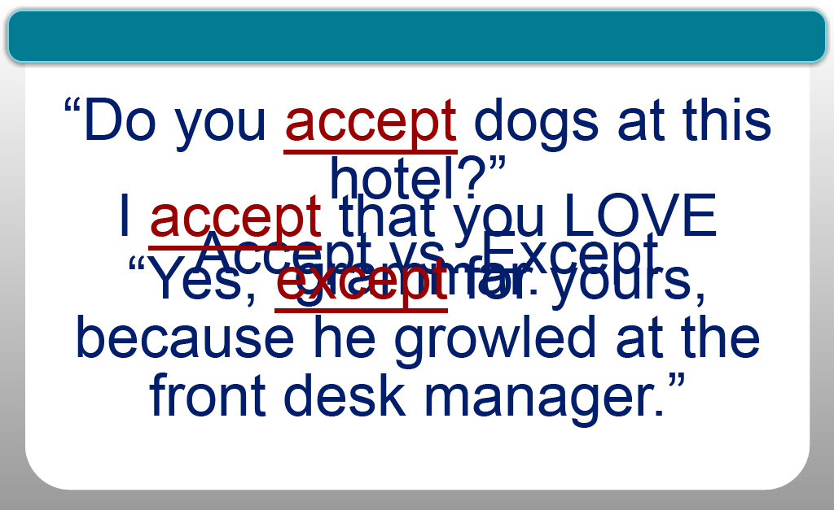
Slide notes
NICOLE: ACCEPT and EXCEPT sound similar, but mean different things.
Accept — starting with an “A” — is a verb and,
in English, it has several different uses.
It can mean to believe or receive something.
For example, “I accept” — that is, I believe — ”that you LOVE grammar.”
[ kissing sound effect ]
“Accept” also means to receive something
as in “Do you accept dogs at this hotel?”
Except — with an E — means to exclude something.
So the response to the question, “Do you accept dogs?”
might be, “Yes, except for yours,
because he growled at the front desk manager.”
Text Captions

Accept vs. Except

I accept that you LOVE grammar.

“Do you accept dogs at this hotel?”

“Yes, except for yours, because he growled at the front desk manager.”

Slide 11 - Affect vs. Effect
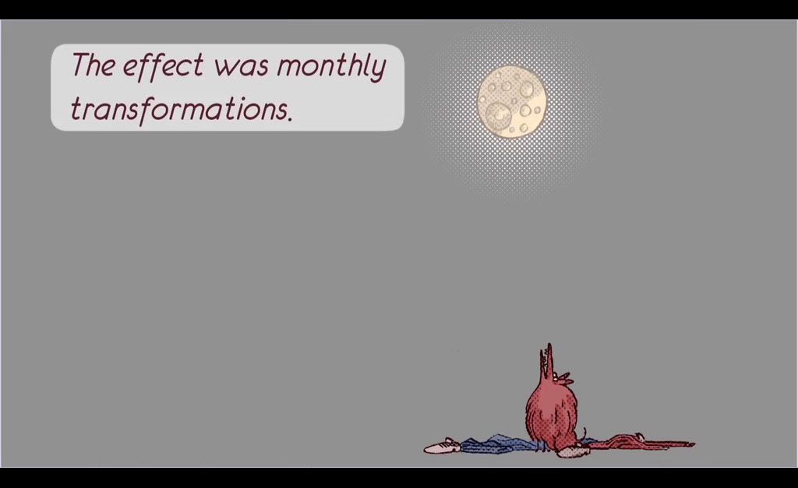
Slide notes
LISA: Affect and effect...it’s a tricky one.
To “affect” something — that’s AFFECT with an A —
means to change it. It’s a verb.
“Effect,” with an E, refers to a result. Effect is a noun.
It refers to a result.
To show these words in action, let’s continue on the dog theme.
George has been bitten by a Pomeranian
not just any Pomeranian, but a werepomeranian,
a distant relative of the werewolf.
George was clearly “affected” by the bite —
that’s AFFECTED, with an A.
The result of that bite —
that is, the EFFECT of the bite
is that, when the moon is full, George...changes...
[ wolf howl sound ]
[ howling wolf sound ]
Text Captions

Affect vs. Effect

Effect = noun = a result

Affect = verb = to change

Slide 12 - Its vs. It's
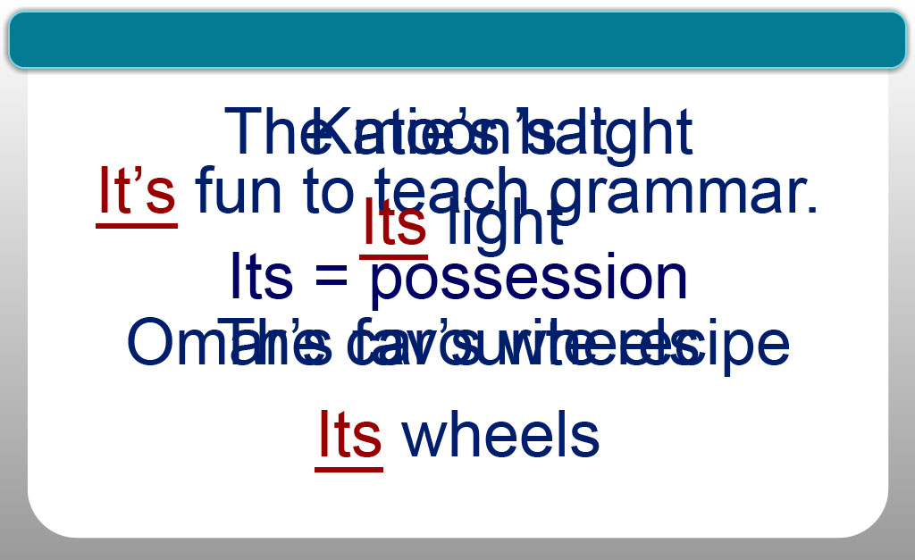
Slide notes
NICOLE: I-T-S and I-T-apostrophe-S.
We HAVE to get this right...because this is perhaps the most
commonly-confused pair of words in the English language,
and no wonder—IT’S not easy.
So let’s start with I-T-apostrophe-S.
There is only one way to use this word: to replace “it is.”
So that’s the rule.
For example: I say, “It’s fun to teach grammar”,
but I can also say “it is” fun to teach grammar.
And THAT is the ONLY way i-t-apostrophe-s is used —
as a substitute for “it is.”
Now here’s where it gets confusing: i-t-s indicates possession.
Normally, when we want to indicate possession,
we use an apostrophe-S.
When we’re talking about people,
we use apostrophe-S for “Katie’s hat,”
“Omar’s favourite recipe,”
“the moon’s light”
or “the car’s wheels.”
Well, what if we refer to the moon or the car as IT?
What happens then?
Well, even though it IS a possessive,
there is no apostrophe.
It doesn’t really make sense but, you know,
English is a quirky critter.
So the correct way to indicate possessive
when talking about a thing is I-T-S,
no apostrophe required.
Text Captions

Its vs. It’s

It is fun to teach grammar.

It’s fun to teach grammar.

Its = possession

The car’s wheels

The moon’s light

Omar’s favourite recipe

Katie’s hat

Its wheels

Its light

Slide 13 - Then vs. Than
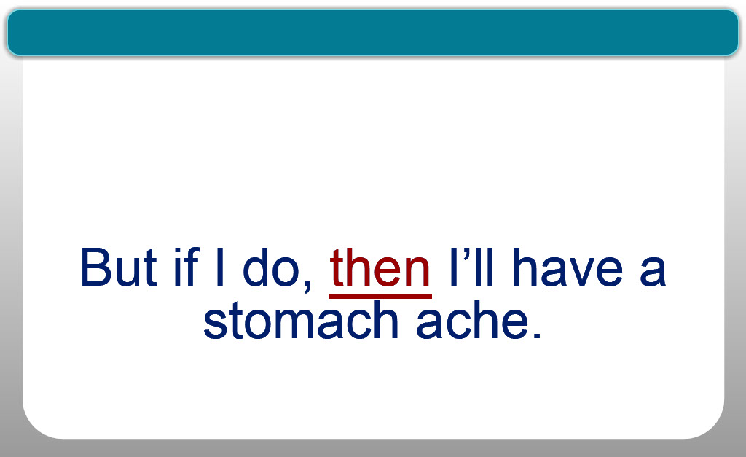
Slide notes
LISA: THEN verus THAN.
“Then” — T-H-E-N — refers to timing or order.
For example: “First we’ll have dinner,
THEN you’ll serve dessert.”
“Than” — T-H-A-N — is used to compare things, as in,
"She makes more money THAN him,”
or “I’d rather eat a cheeseburger THAN a salad.”
Let’s see them both in action.
“I’d rather eat a cheeseburger THAN a salad.
But if I do, THEN I’ll have a stomach ache.”
Text Captions

Then vs. Than

you’ll serve dessert.

then

then

First we’ll have dinner,

him.

than

than

She makes more money

a salad.

than

than

I’d rather eat a cheeseburger

But if I do, then I’ll have a stomach ache.

But if I do, then I’ll have a stomach ache.

I’d rather eat a cheeseburger
than a salad.

I’d rather eat a cheeseburger
than a salad.

Slide 14 - Lets vs. Let's
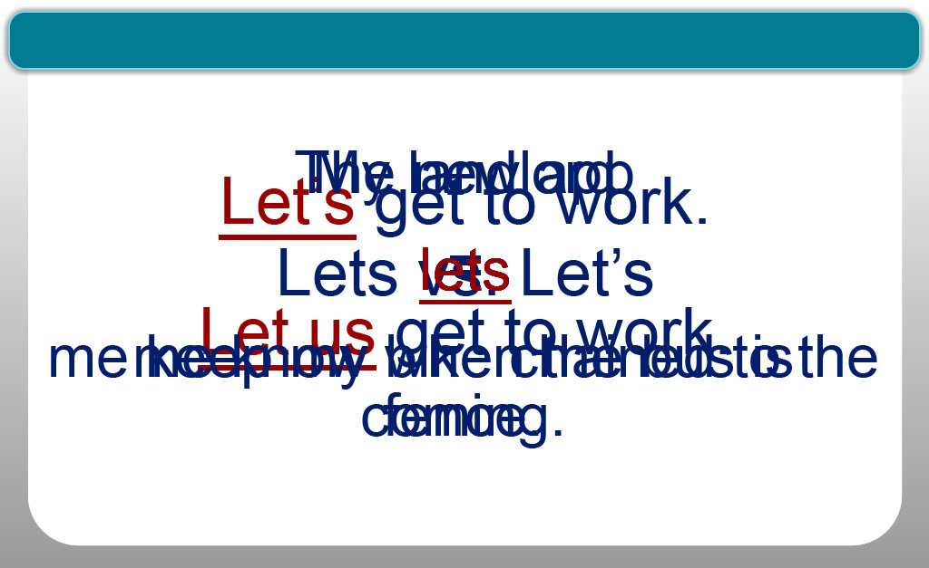
Slide notes
NICOLE: Lets and let’s. This shouldn’t be a problem, but it is.
L-e-t-apostrophe-s is a contraction.
What it really means is “Let us,”
which I know sounds hopelessly old-fashioned.
So, “Let’s get to work” means the same thing as
“Let us get to work.”
The apostrophe indicates it’s a contraction — because the apostrophe
takes the place of the missing characters.
But “lets” without an apostrophe means the same thing as “allows,”
as in, “The new app LETS me know when the bus is coming”
or “My landlord LETS me keep my bike chained to the fence.”
Text Captions

Lets vs. Let’s

Let’s get to work.
=
Let us get to work.

me know when the bus is coming.

lets

lets

The new app

lets

me keep my bike chained to the fence.

lets

My landlord

Slide 15 - You're vs. Your
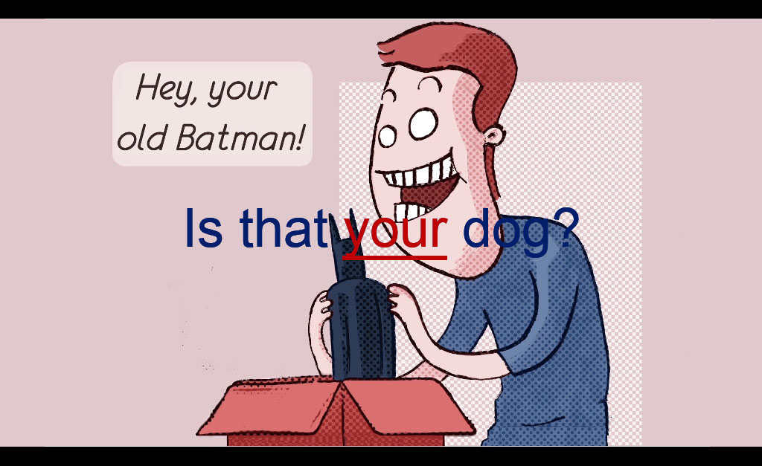
Slide notes
LISA: Moving on: Your versus You’re.
Here’s another example of a commonly confused pair of words
in which the apostrophe is the clue
that will help you get it right.
YOUR — that’s Y-O-U-R — means something belonging to you,
or something made or done by you,
as in, “Is that your dog?”,
which is the same as saying,
“Is that the dog belonging to you?”
Or here's another example: digging through a box of childhood toys,
you might find “your old Batman.”
But let’s change that “your” to Y-O-U-apostrophe-R-E
and the message is changed completely.
“You’re old, Batman,” tells my favourite superhero
it’s time to retire.
Text Captions

You’re vs. Your

Your = something belonging to you

Is that your dog?

Is that your dog?

Slide 16 - Learning Outcomes
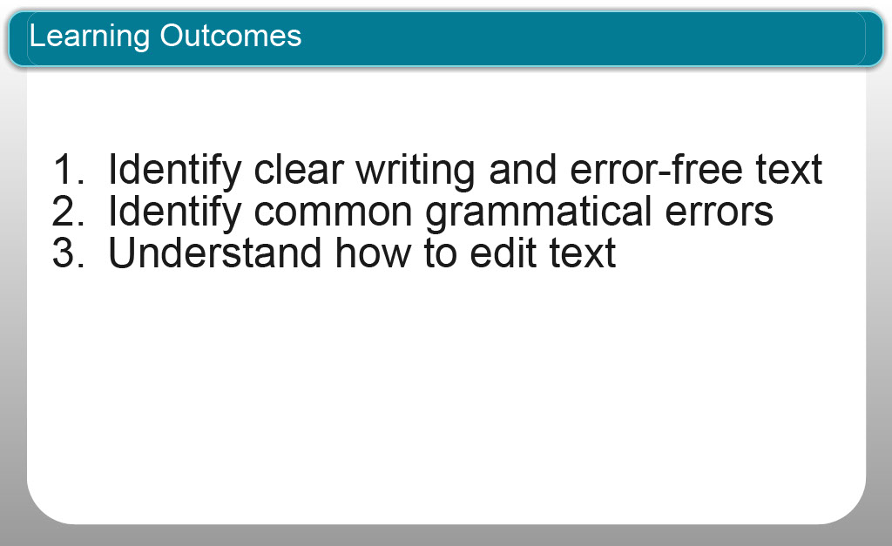
Slide notes
NICOLE: Now that you’ve finished this module you should be able to:
you should be better prepared to:
Identify clear writing with error-free text
Identify common grammatical errors
Understand how to edit text
Text Captions

Identify clear writing and error-free text
Identify common grammatical errors
Understand how to edit text

Learning Outcomes

Slide 17 - Topic Quiz
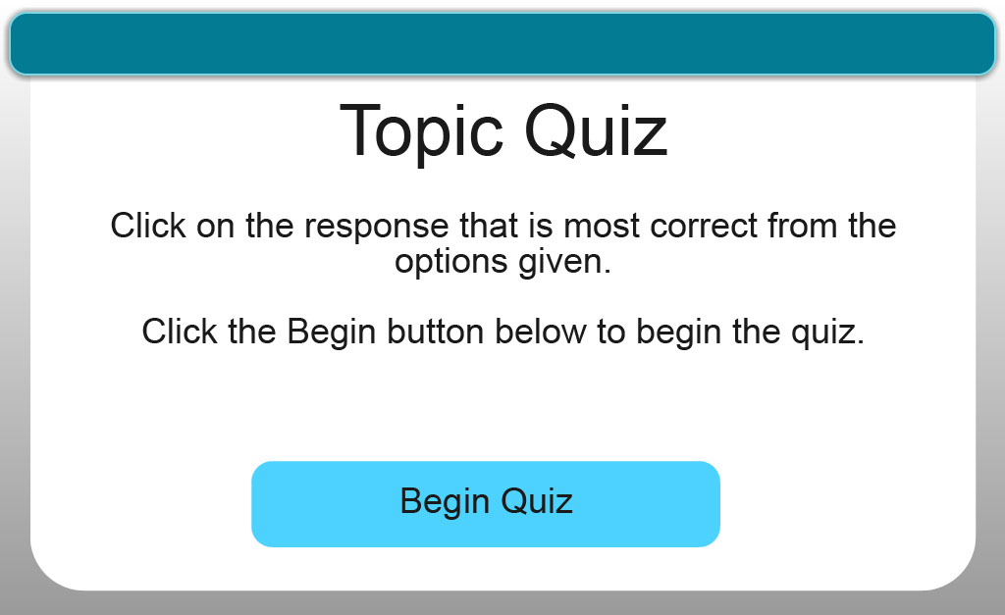
Slide notes
Text Captions

Topic Quiz

Begin Quiz

Quiz Question 1 – Multiple Choice
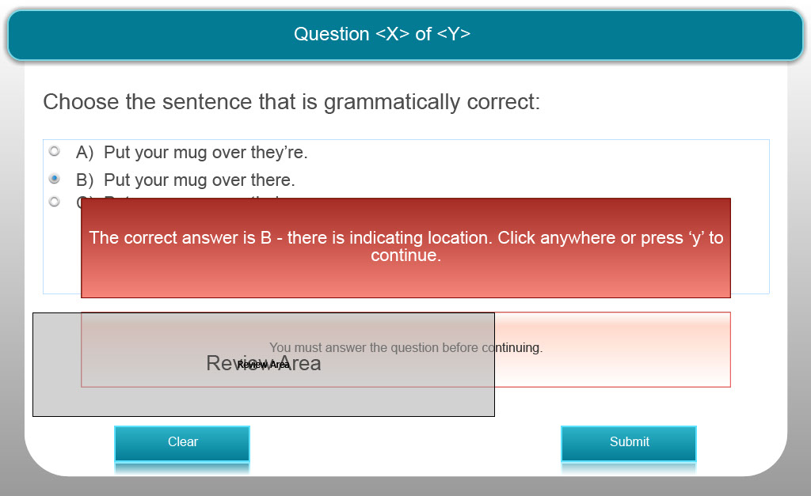
Slide notes
Text Captions

Choose the sentence that is grammatically correct:

A) Put your mug over they’re.

B) Put your mug over there.

C) Put your mug over their.

The correct answer is B - there is indicating location.

Quiz Question 2 – Multiple Choice
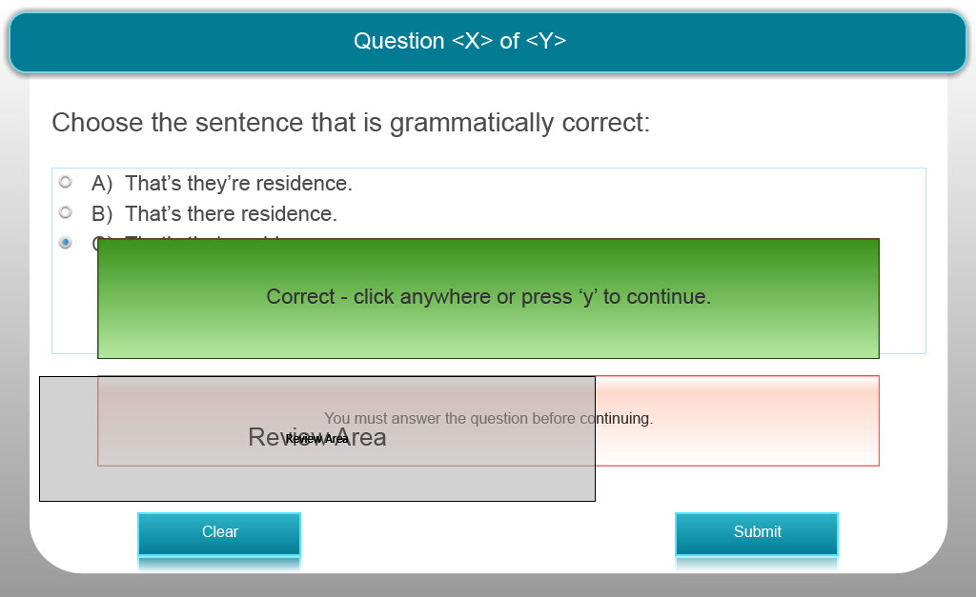
Slide notes
Text Captions

Choose the sentence that is grammatically correct:

A) That’s they’re residence.

B) That’s there residence.

C) That’s their residence.

The correct answer is C - their is possessive.

Quiz Question 3 – Multiple Choice
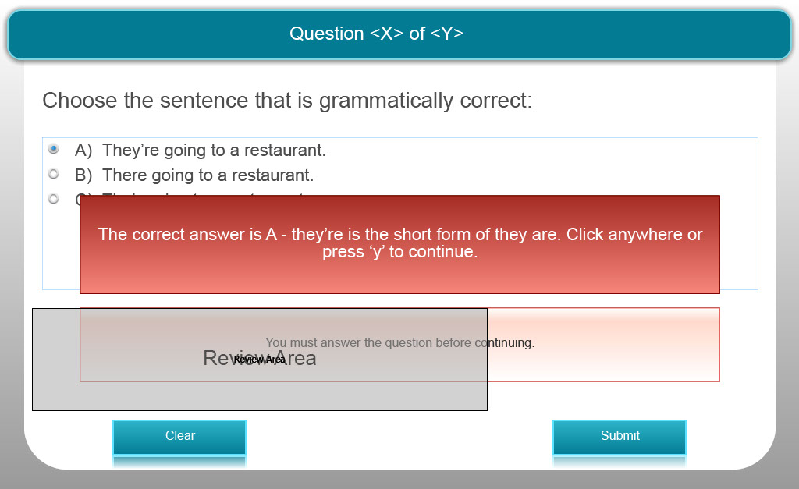
Slide notes
Text Captions

Choose the sentence that is grammatically correct:

A) They’re going to a restaurant.

B) There going to a restaurant.

C) Their going to a restaurant.

The correct answer is A - they’re is the short form of they are.

Quiz Question 4 – Multiple Choice
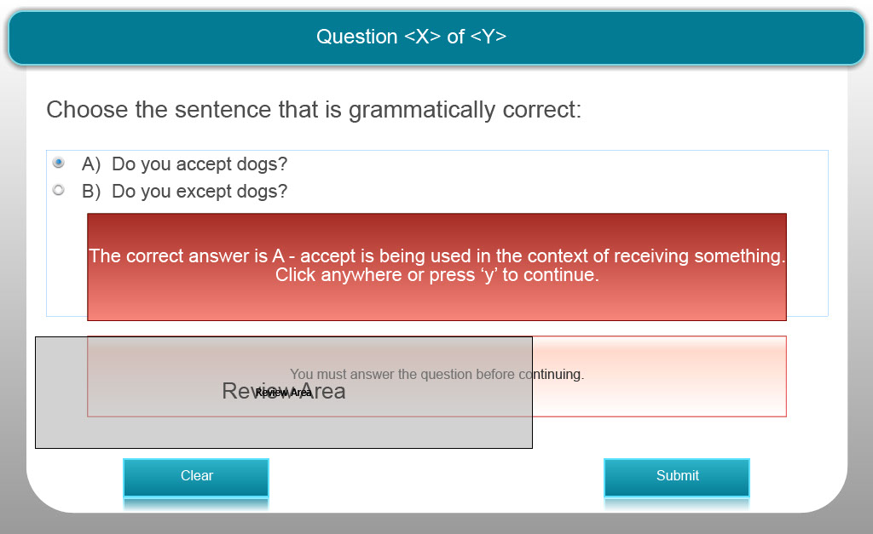
Slide notes
Text Captions

Choose the sentence that is grammatically correct:

A) Do you accept dogs?

B) Do you except dogs?

The correct answer is A - accept is being used in the context of receiving something.

Quiz Question 5 – Multiple Choice
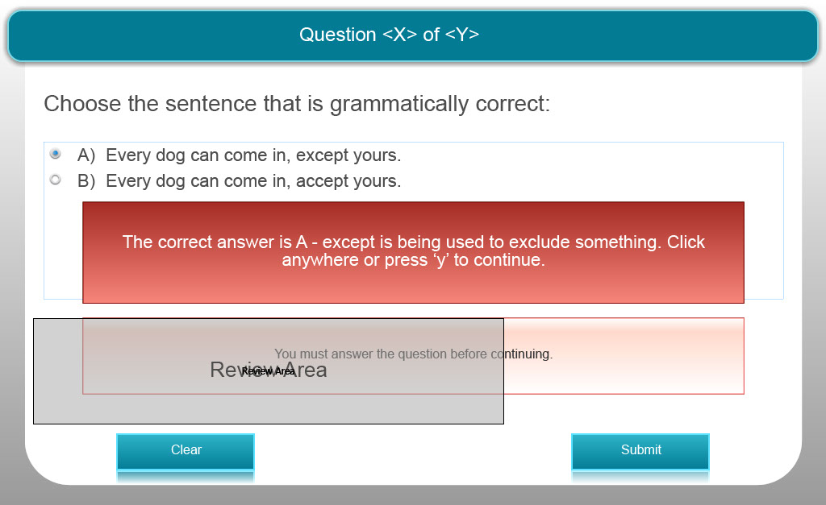
Slide notes
Text Captions

Choose the sentence that is grammatically correct:

A) Every dog can come in, except yours.

B) Every dog can come in, accept yours.

The correct answer is A - except is being used to exclude something.

Quiz Question 6 – Multiple Choice
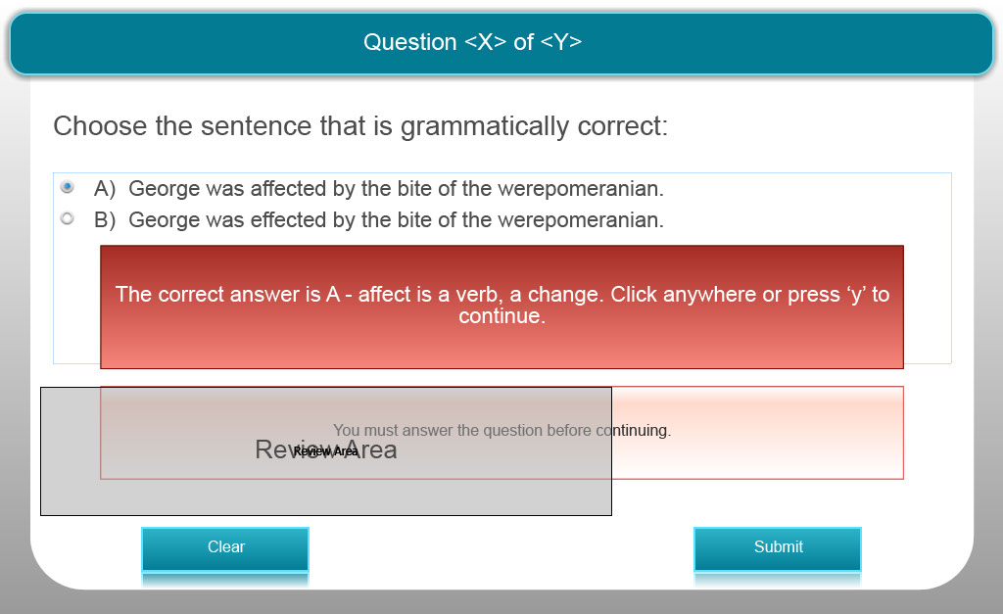
Slide notes
Text Captions

Choose the sentence that is grammatically correct:

A) George was affected by the bite of the werepomeranian.

B) George was effected by the bite of the werepomeranian.

The correct answer is A - affect is a verb, a change.

Quiz Question 7 – Multiple Choice 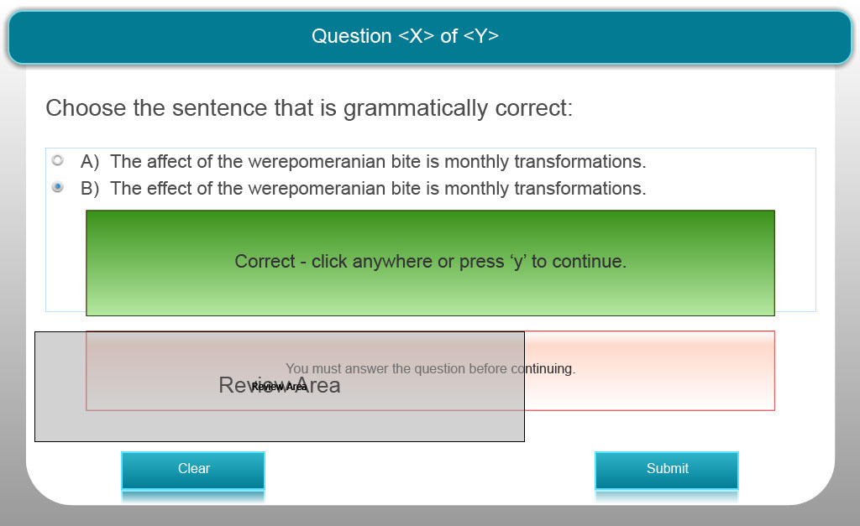
Slide notes
Text Captions

Choose the sentence that is grammatically correct:

A) The affect of the werepomeranian bite is monthly transformations.

B) The effect of the werepomeranian bite is monthly transformations.

The correct answer is B - effect is a noun, a result.

Quiz Question 8 – Multiple Choice
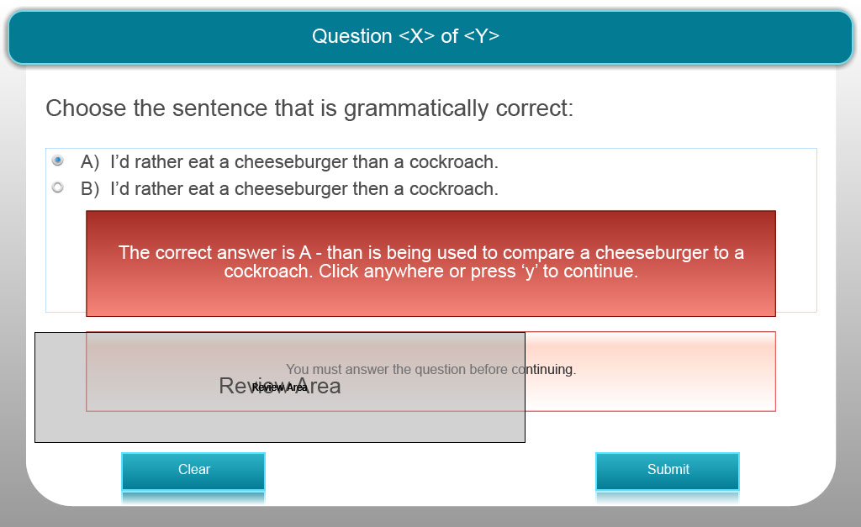
Slide notes
Text Captions

Choose the sentence that is grammatically correct:

A) I’d rather eat a cheeseburger than a cockroach.

B) I’d rather eat a cheeseburger then a cockroach.

The correct answer is A - than is being used to compare a cheeseburger to a cockroach.

Quiz Question 9 – Multiple Choice
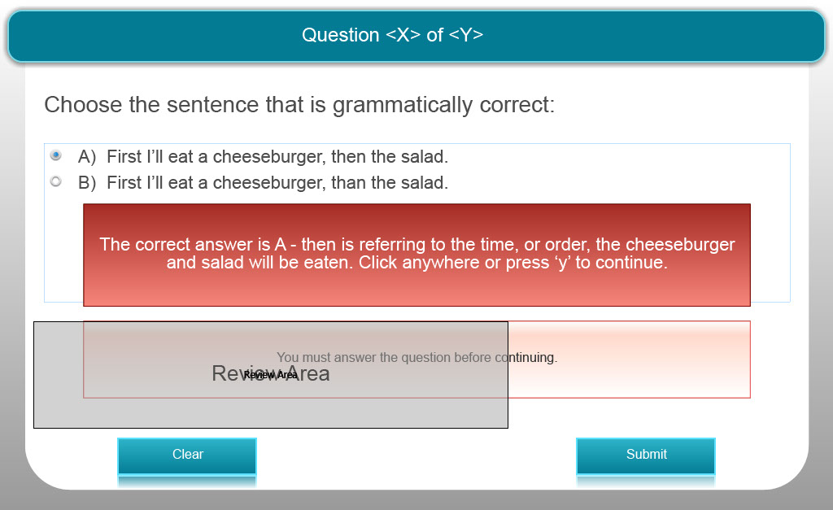
Slide notes
Text Captions

Choose the sentence that is grammatically correct:

A) First I’ll eat a cheeseburger, then the salad.

B) First I’ll eat a cheeseburger, than the salad.

The correct answer is A - then is referring to the time, or order, the cheeseburger and salad will be eaten.

Quiz Question 10 – Multiple Choice
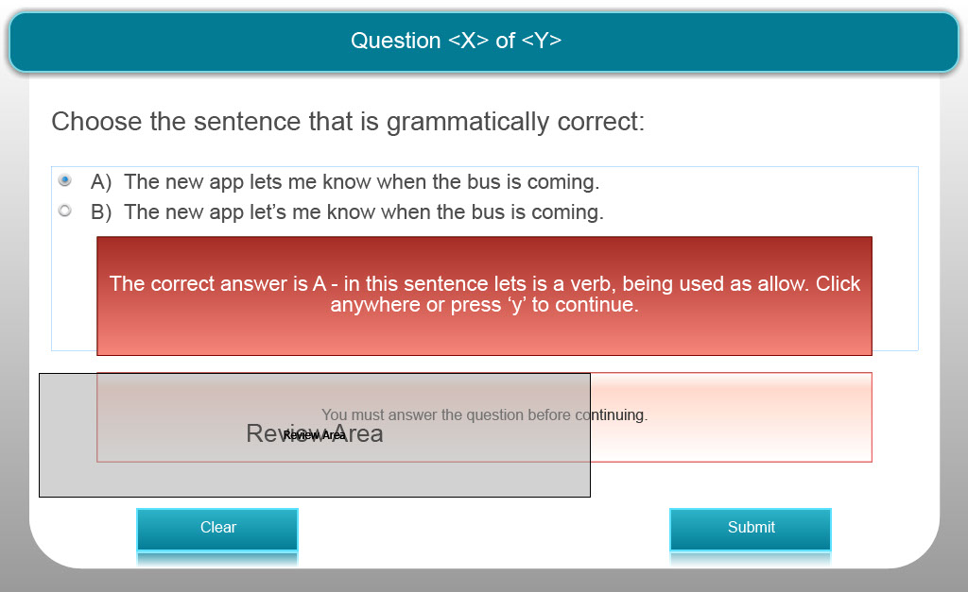
Slide notes
Text Captions

Choose the sentence that is grammatically correct:

A) The new app lets me know when the bus is coming.

B) The new app let’s me know when the bus is coming.

The correct answer is A - in this sentence lets is a verb, being used as allow.

Quiz Question 11 – Multiple Choice
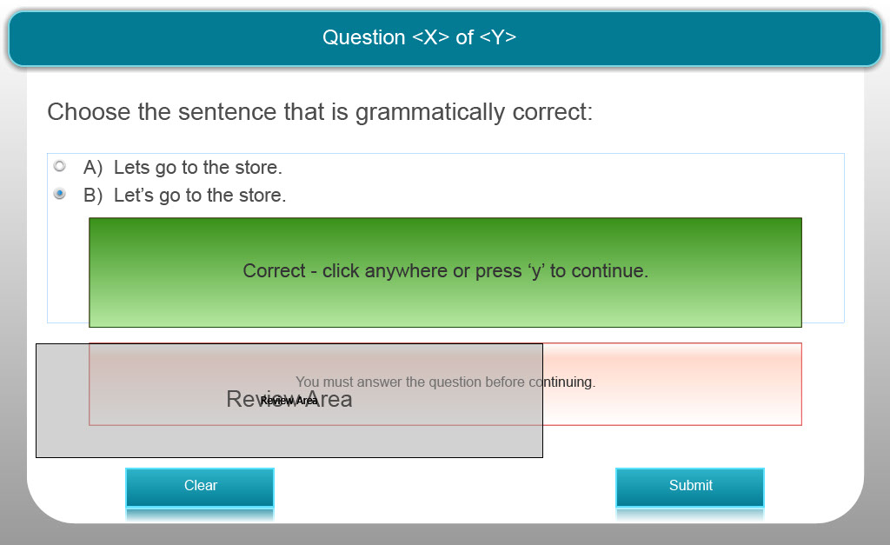
Slide notes
Text Captions

Choose the sentence that is grammatically correct:

A) Lets go to the store.

B) Let’s go to the store.

The correct answer is B - in this sentence let’s is the short form for let us.

Quiz Question 12 – Multiple Choice
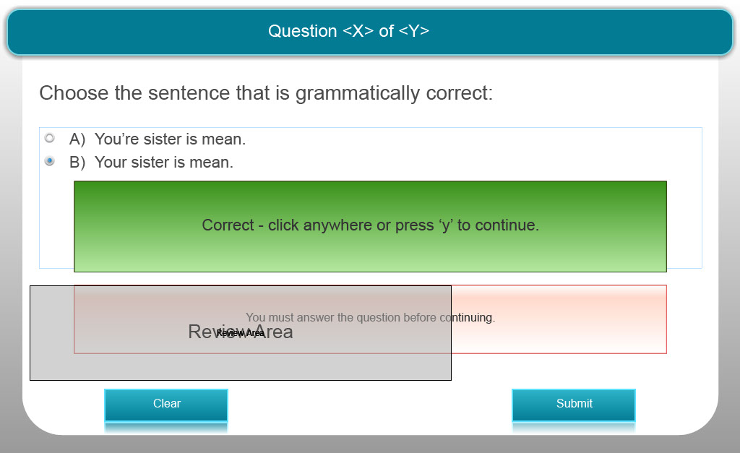
Slide notes
Text Captions

Choose the sentence that is grammatically correct:

A) You’re sister is mean.

B) Your sister is mean.

The correct answer is B - in this sentence your is possessive.

Quiz Question 13 – Multiple Choice
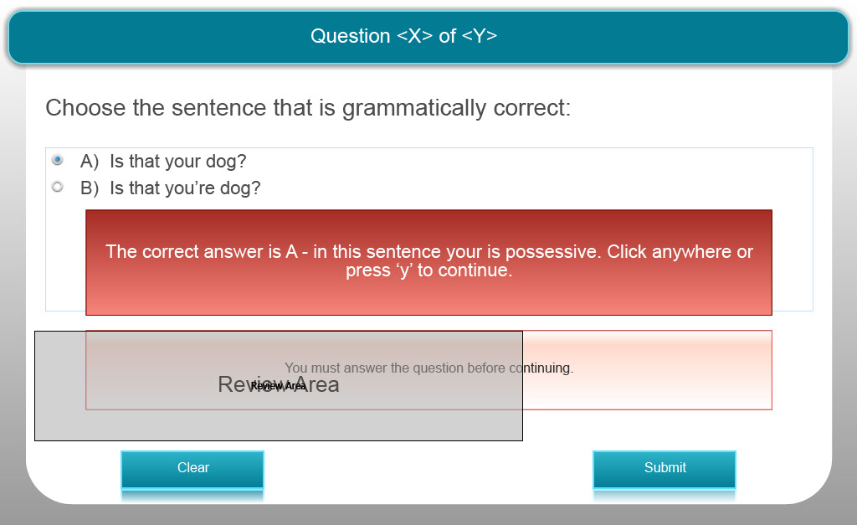
Slide notes
Text Captions

Choose the sentence that is grammatically correct:

A) Is that your dog?

B) Is that you’re dog?

The correct answer is A - in this sentence your is possessive.

Quiz Question 14 – Multiple Choice
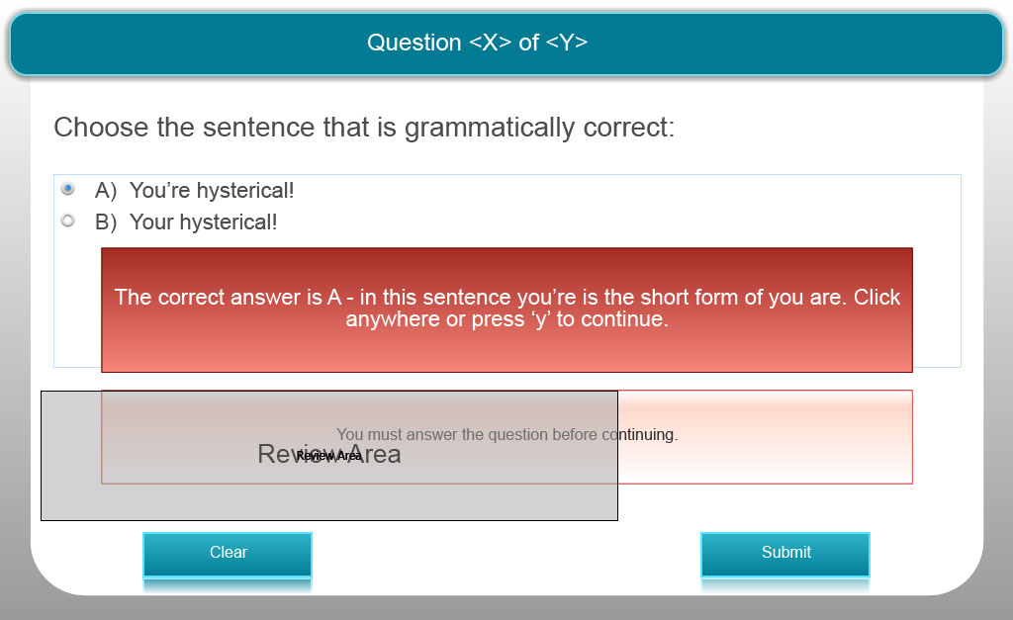
Slide notes
Text Captions

Choose the sentence that is grammatically correct:

A) You’re hysterical!

B) Your hysterical!

The correct answer is A - in this sentence you’re is the short form of you are.

Quiz Question 15 – Multiple Choice
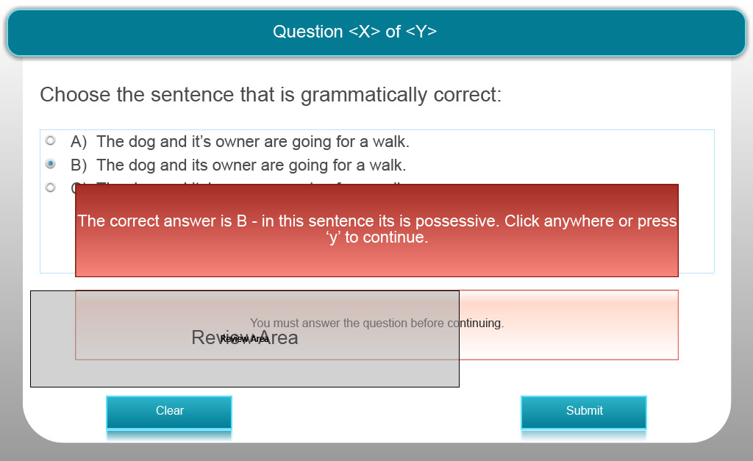
Slide notes
Text Captions

Choose the sentence that is grammatically correct:

A) The dog and it’s owner are going for a walk.

B) The dog and its owner are going for a walk.

C) The dog and its’ owner are going for a walk.

The correct answer is B - in this sentence its is possessive.
Quiz Question 16 – Multiple Choice
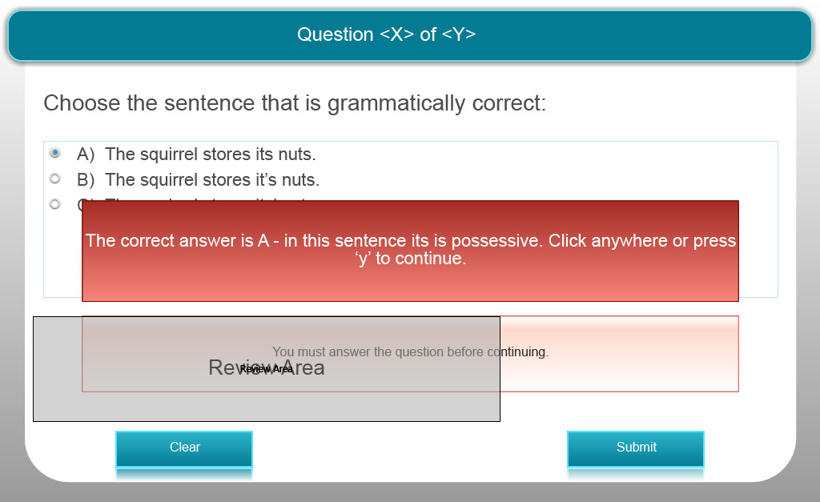
Slide notes
Text Captions

Choose the sentence that is grammatically correct:

A) The squirrel stores its nuts.

B) The squirrel stores it’s nuts.

C) The squirrel stores its’ nuts.

The correct answer is A - in this sentence its is possessive.
Quiz Question 17 – Multiple Choice 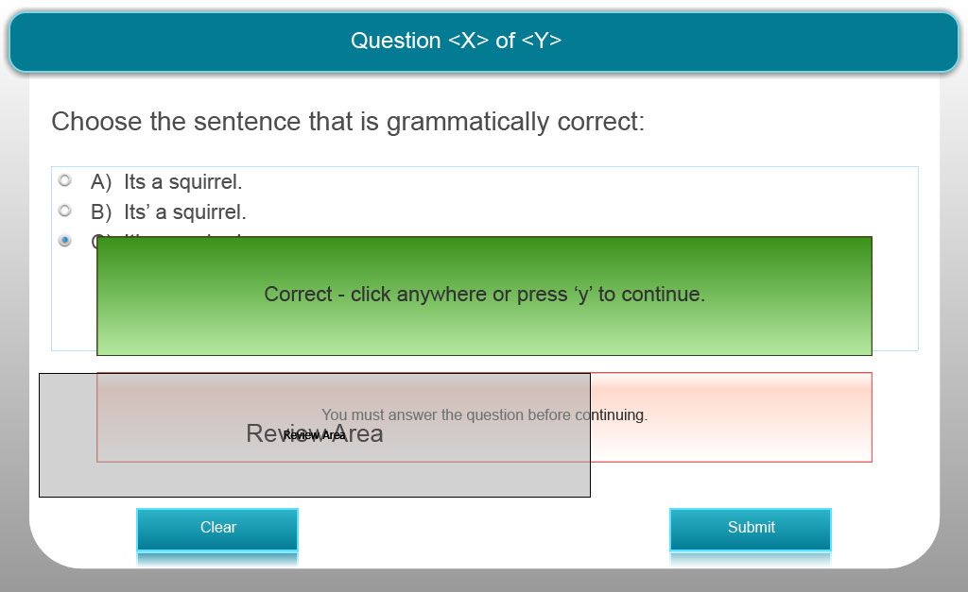
Slide notes
Text Captions

Choose the sentence that is grammatically correct:

A) Its a squirrel.

B) Its’ a squirrel.

C) It’s a squirrel.

The correct answer is C - in this sentence it’s is a short form for it is.

Slide 29 - Congratulations!
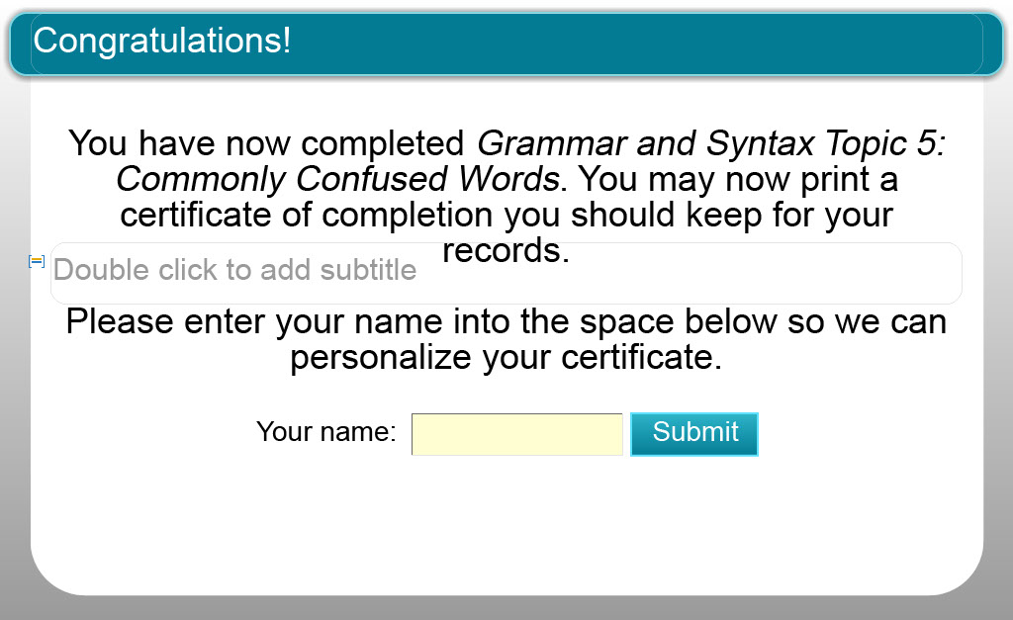
Slide notes
Text Captions

You have now completed Grammar and Syntax Topic 5: Commonly Confused Words. You may now print a certificate of completion you should keep for your records. Please enter your name into the space below so we can personalize your certificate.

Congratulations!

Your name:

Slide 30 - Certificate of Completion
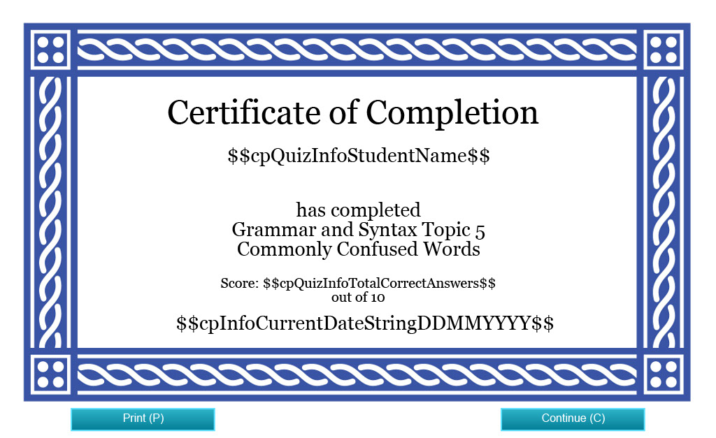
Slide notes
Text Captions

Certificate of Completion

has completed
Grammar and Syntax Topic 5
Commonly Confused Words

Slide 31 - Credits

Slide notes
Text Captions

Credits

Funding for this project was provided by the Ministry of Training, Colleges and Universities (MTCU) 2014-2015 Shared Online Course Fund.

Slide 32 - Credits
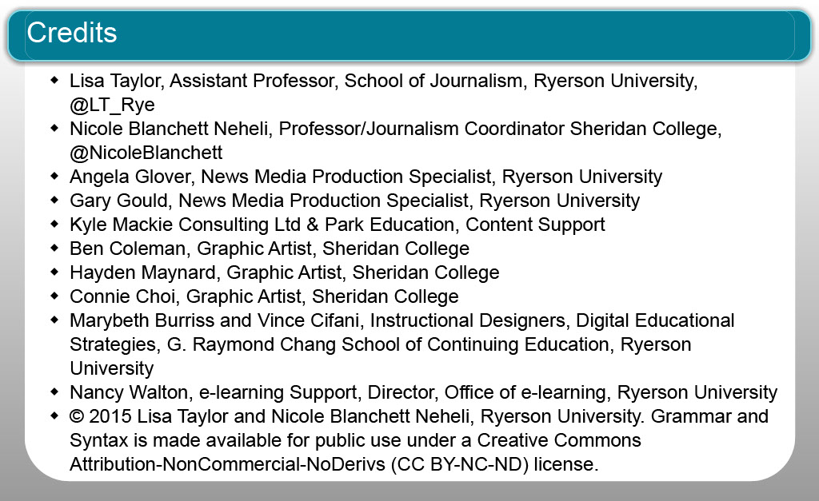
Slide notes
Text Captions

Lisa Taylor, Assistant Professor, School of Journalism, Ryerson University, @LT_Rye
Nicole Blanchett Neheli, Professor/Journalism Coordinator Sheridan College, @NicoleBlanchett
Angela Glover, News Media Production Specialist, Ryerson University
Gary Gould, News Media Production Specialist, Ryerson University
Kyle Mackie Consulting Ltd & Park Education, Content Support
Ben Coleman, Graphic Artist, Sheridan College
Hayden Maynard, Graphic Artist, Sheridan College
Connie Choi, Graphic Artist, Sheridan College
Marybeth Burriss and Vince Cifani, Instructional Designers, Digital Educational Strategies, G. Raymond Chang School of Continuing Education, Ryerson University
Nancy Walton, e-learning Support, Director, Office of e-learning, Ryerson University
© 2015 Lisa Taylor and Nicole Blanchett Neheli, Ryerson University. Grammar and Syntax is made available for public use under a Creative Commons Attribution-NonCommercial-NoDerivs (CC BY-NC-ND) license.

Credits

