Slide 1 - Topic 3
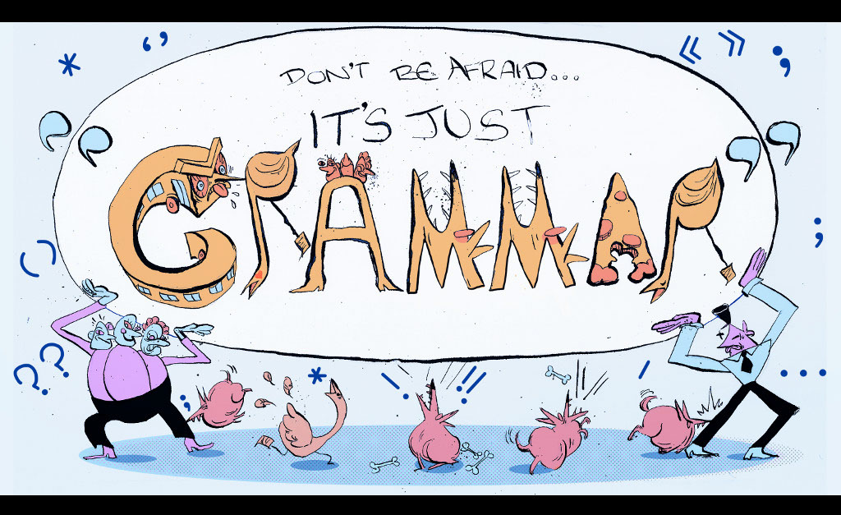
Slide notes
Text Captions

Don’t Be Afraid… It’s Just “Grammar”

Slide 2 - Topic 3: Making Sentences Agreeable
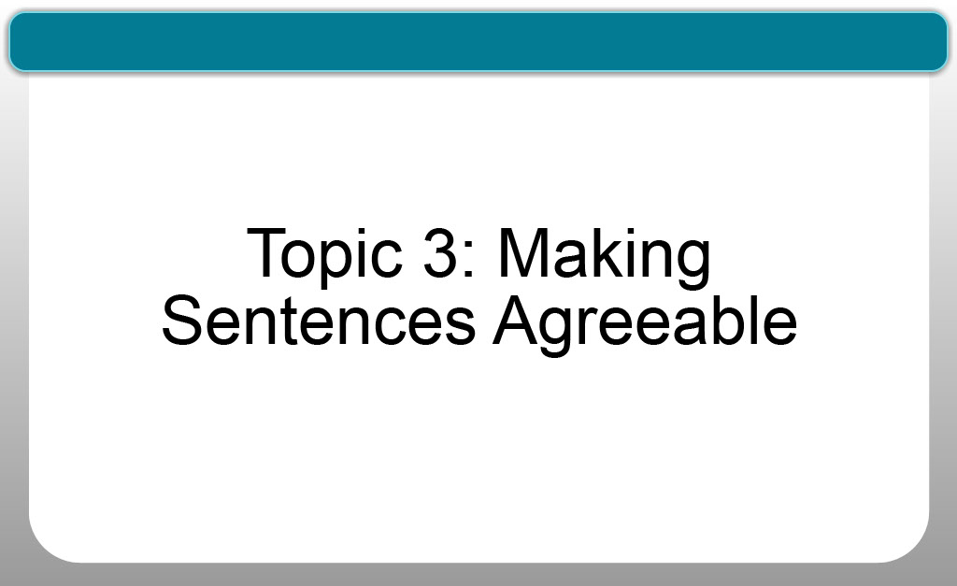
Slide notes
Text Captions

Topic 3: Making Sentences Agreeable

Slide 3 - Topic Navigation
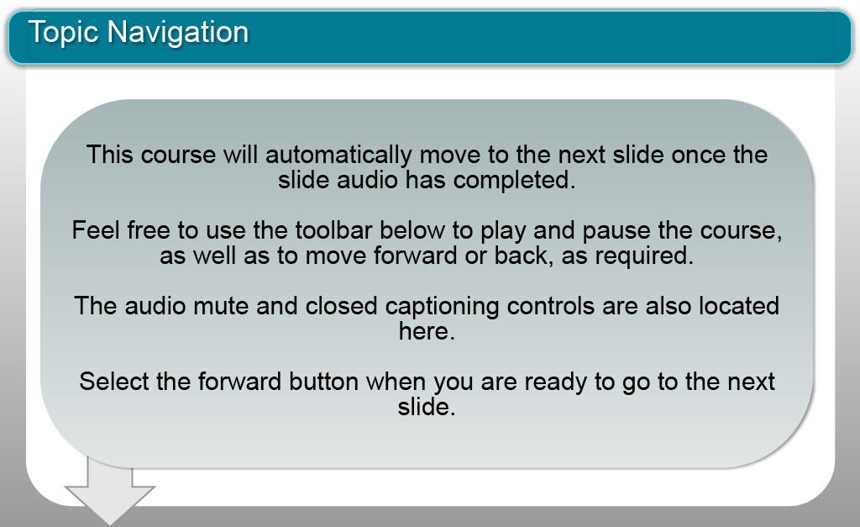
Slide notes
Text Captions

Topic Navigation

This course will automatically move to the next slide once the slide audio has completed.

Feel free to use the toolbar below to play and pause the course, as well as to move forward or back, as required.

The audio mute and closed captioning controls are also located here.

Select the forward button when you are ready to go to the next slide.

Slide 4 - Introduction

Slide notes
Text Captions
LISA: I'm Lisa Taylor.
NICOLE: And I'm Nicole Blanchett Neheli. We’re two journalism professors who both see our students struggle with grammar. So, we created a series of videos to help clarify some of the most confusing grammatical rules.
LISA: One of the trickiest aspects of structuring a sentence can be ensuring that all its parts agree. The basic rule of subject verb agreement is that if the subject, or noun, is singular the verb must follow suit.
NICOLE: So for example, if Lisa was doing this video by herself, you would say Lisa makes a video. But since Lisa and I are making this video together, you would say Lisa and Nicole make a video. When the subject is singular the verb needs an s, but when there is more than one subject or the subject is plural there is no s on the verb. And yes, this is kind of counterintuitive as it’s the opposite of what you’d do to make a noun plural, but that’s just one of those nutty rules of grammar.
LISA: In this video we’re going to cover some of the most common subject verb agreement errors and, by the end of this module, you’ll be able to identify and fix them. So let’s get started.
Slide 5 - Singular Subjects

Slide notes
LISA: If you were to write:
Kim Kardashian make headlines for no apparent reason.
That is incorrect. It should read,
Kim Kardashian makes headlines for no apparent reason.
Text Captions

Kim Kardashian make headlines for no apparent reason.

Kim Kardashian makes headlines for no apparent reason.

Slide 6 - Singular Subjects

Slide notes
NICOLE: Or, if you write,
Andrew Wiggins jump higher than Kyle Lowry.
That is incorrect. It should actually read:
Andrew Wiggins jumps higher than Kyle Lowry.
Because the subject, Andrew Wiggins, is singular,
the verb, jumps, also has to be singular,
which means it has an s on the end.
Text Captions

Andrew Wiggins jump higher than Kyle Lowry.

Andrew Wiggins jumps higher than Kyle Lowry.

Slide 7 - Plural Subjects

Slide notes
LISA: And, remember,
if you have more than one subject or a plural subject -
there's no “s” on the verb. It’s not,

Dion and Phil can’t makes it to the playoffs.
But instead,
Dion and Phil can’t make it to the playoffs.
If there’s more than one subject or the subject is plural,
there is no “s” on the verb.
Text Captions

Dion and Phil can’t makes it to the playoffs.

Dion and Phil can’t make it to the playoffs.

Slide 8 - Collective Nouns

Slide notes
NICOLE: Next up another confusing part of grammar -
collective nouns.
This is a tricky concept because
it’s a noun that is singular but refers to a group of people,
like a ballet company.
"Ballet company” is a singular noun
but includes a number of dancers.
Or what about the government?
“Government” is also a singular noun,
but it’s one that refers to thousands of people
doing all kinds of different jobs.
Text Captions

Collective noun:

a noun that is singular but refers to a group of people

Ballet company

Government

Slide 9 - Collective Nouns

Slide notes
LISA: Here's a picture that illustrates the rule.
"The teachers are getting coffee."
"Teachers" is a plural noun,
so you have to use the verb "are."
But the staff IS getting coffee
because "staff" is a collective noun
that refers to all teachers as a single unit.
One unit means you use a singular verb,
in this case "is" instead of "are."
LISA: Here’s a picture that helps illustrate this rule.
The people are getting coffee -
people is a plural noun so you have to use the verb are.
But the staff IS getting coffee because,
although the staff is made up of a number of people,
in the context of this sentence
they are being referred to as one unit...
in this case with one pair of pants.
One unit means you use a singular verb,
in this case IS instead of ARE.
Text Captions

Slide 10 - Collective Nouns
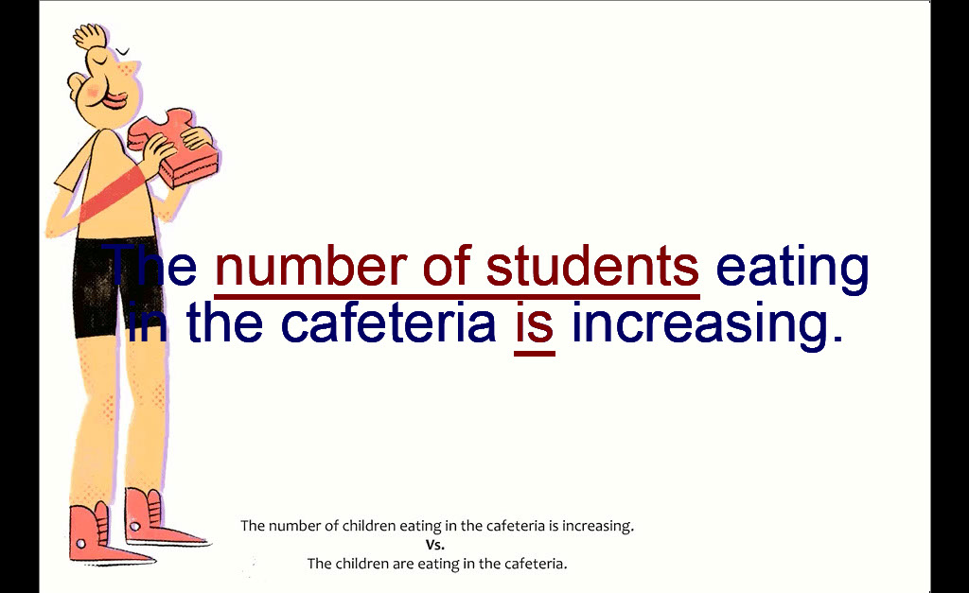
Slide notes
NICOLE: Here’s another example.
The students are eating in the cafeteria.
Easy enough, “students” is a plural subject
and “are” is a plural verb.
But, what if I want to talk about an increase
in the number of students who are eating?
If I write,
“The number of students eating in the cafeteria are increasing”
it’s grammatically incorrect, because
because now my subject is “the number” - not students -
and my verb has to be singular.
It should actually say,
“The number of students eating in the cafeteria is increasing”
because “number,” in this case, is a collective noun
referring to all of the students in the cafeteria.
Text Captions

The students are eating in the cafeteria.

The students are eating in the cafeteria.

The students are eating in the cafeteria.

The number of students eating in the cafeteria is increasing.

The number of students eating in the cafeteria is increasing.

The number of students eating in the cafeteria is increasing.

Slide 11 - Pronouns
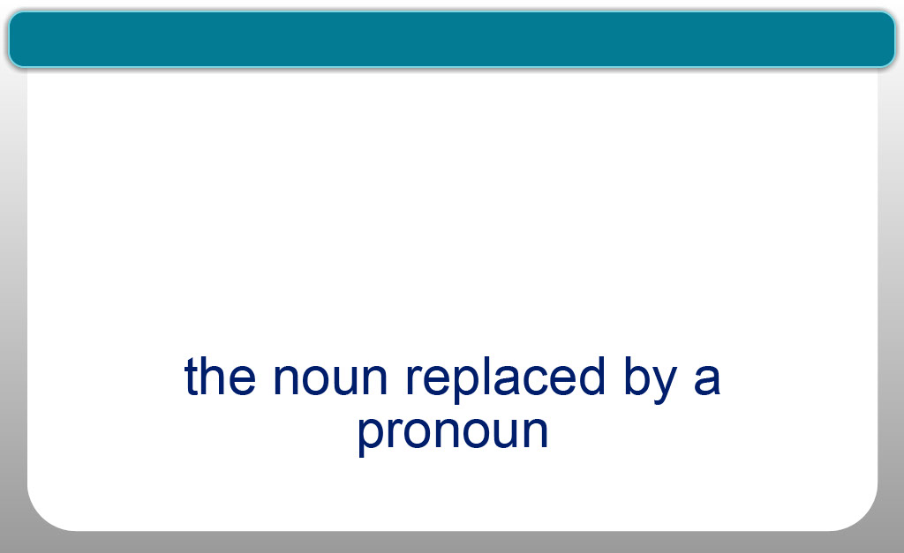
Slide notes
NICOLE: Now we’re going to talk about pronouns.
The goal in all writing is to
communicate as clearly as possible;
that is why it is so important to use pronouns correctly.
The pronoun replaces a noun that
has come earlier in the sentence or paragraph.
Its antecedent is the noun that it replaced.
LISA: So if I write "Jimmy Fallon is funny",
Jimmy Fallon is the subject.
If I then say, “He makes me laugh.”,
Jimmy Fallon is the antecedent
or the noun that was replaced,
and “he” is the pronoun,
the word that replaced the noun or subject.
This sentence is grammatically correct because
both he and Jimmy Fallon are singular.
If your antecedent is singular,
then your pronoun also has to be singular.
NICOLE: Another important rule is that
sometimes you can’t use a pronoun
if there are multiple nouns, or subjects,
named previously in the sentence.
“They” works as a pronoun to replace several people,
but let’s take a look at a case where a pronoun wouldn’t work.
Text Captions

Pronoun:

replaces a noun that has come earlier in the sentence

Antecedent:

the noun replaced by a pronoun

Jimmy Fallon is funny. He makes me laugh.

Jimmy Fallon is funny. He makes me laugh.

Jimmy Fallon is funny. He makes me laugh.

Singular pronoun = Singular antecedent

Multiple subjects = Can’t always use a pronoun

Slide 12 - Pronouns
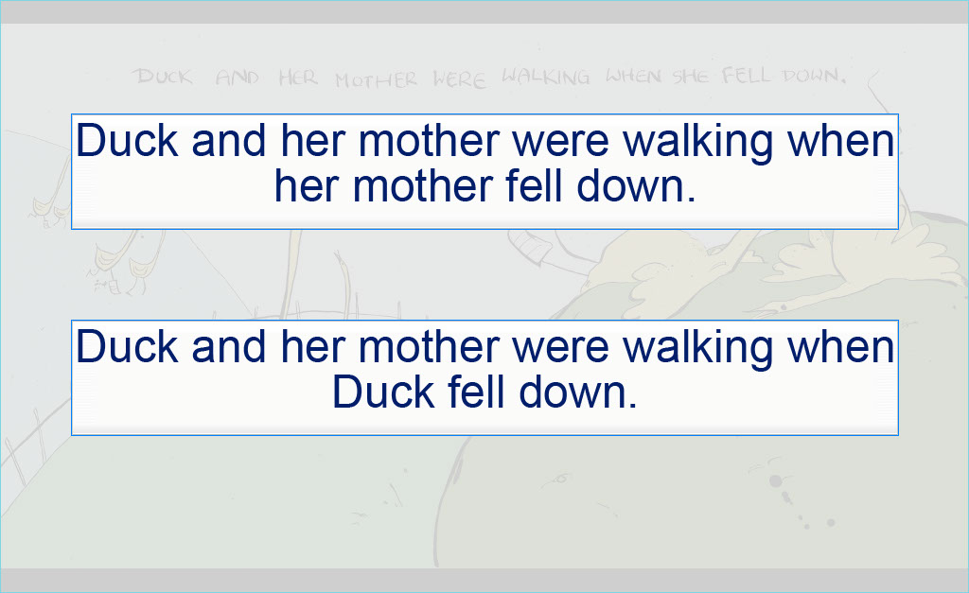
Slide notes
LISA: In this illustration duck and her mother are walking
and “she fell down.”
But who is the pronoun “she” referring to?
Duck, or her mother? There is no way to tell.
To correct this sentence you would have to write,
Duck and her mother were walking when her mother fell down.
Or, Duck and her mother were walking when Duck fell down.
You can’t use a pronoun “she” to refer to
the character who has fallen in this instance
because it’s impossible to tell who you are referring to.
Text Captions

Duck and her mother were walking when her mother fell down.

Duck and her mother were walking when Duck fell down.

Slide 13 - Singular and Plural Pronouns
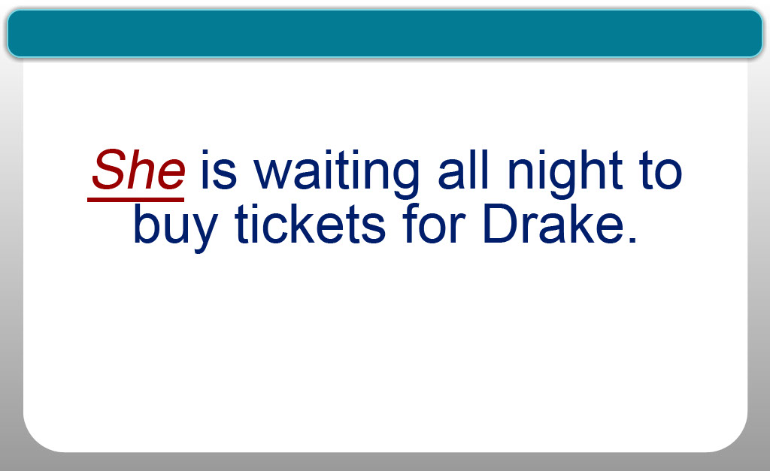
Slide notes
NICOLE: And remember:
plural pronouns need plural antecedents,
singular pronouns need singular antecedents.
If Sheila is waiting all night to buy tickets for Drake,
if you wanted to replace Sheila with a pronoun you can’t say
“We is waiting all night to buy tickets for Drake”
because "we" is a plural pronoun.
You need to use the singular “she.”
So the correct way to write the sentence would be,
“She is waiting all night to buy tickets for Drake.”
Text Captions

Sheila is waiting all night to buy tickets for Drake.

We is waiting all night to buy tickets for Drake.

She is waiting all night to buy tickets for Drake.

Slide 14 - Module Recap

Slide notes
LISA: So to recap:
Subjects and verbs have to agree.
If the subject is singular then the verb has to be singular,
which means the verb has an s on the end.
If there is more than one subject or the subject is plural,
the verb must be plural
and then there is no s on the end of the word.
NICOLE: A collective noun is singular,
but refers to a group of things or people.
For example, the staff is made up of more than one person,
but the staff is one unit getting coffee.
It’s a singular noun requiring a singular verb.
LISA: The pronoun replaces a noun
that has come earlier in the sentence.
Its antecedent is the noun that it replaced.
If your antecedent is singular, then
your pronoun also has to be singular.
And sometimes you can’t use a pronoun
if there are multiple subjects, because there's just no way
to tell which subject you are referring to.
Text Captions

Module Recap

He jumps higher than Kyle Lowry.

Dion and Phil can’t make it to the playoffs.

Jimmy Fallon is funny. He makes me laugh.

Slide 15 - Learning Outcomes
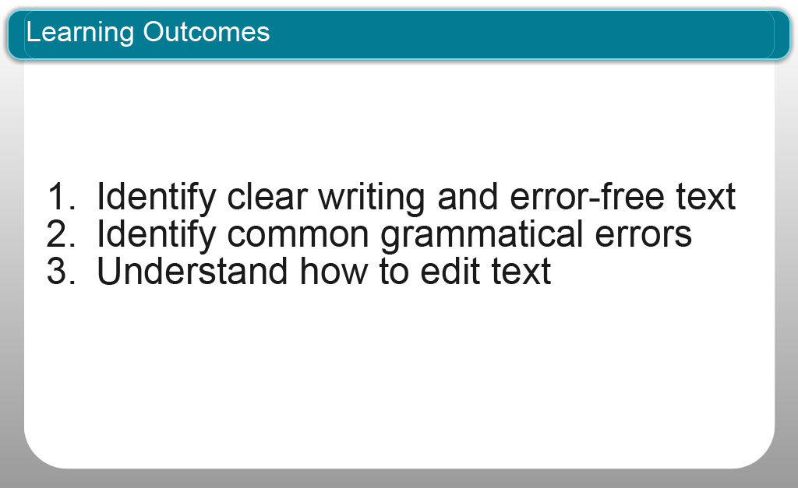
Slide notes
NICOLE: Now that you’ve finished this module you should be able to:
you should be better prepared to:
Identify clear writing with error-free text
Identify common grammatical errors
Understand how to edit text
Text Captions

Identify clear writing and error-free text
Identify common grammatical errors
Understand how to edit text
Learning Outcomes

Slide 16 - Topic Quiz
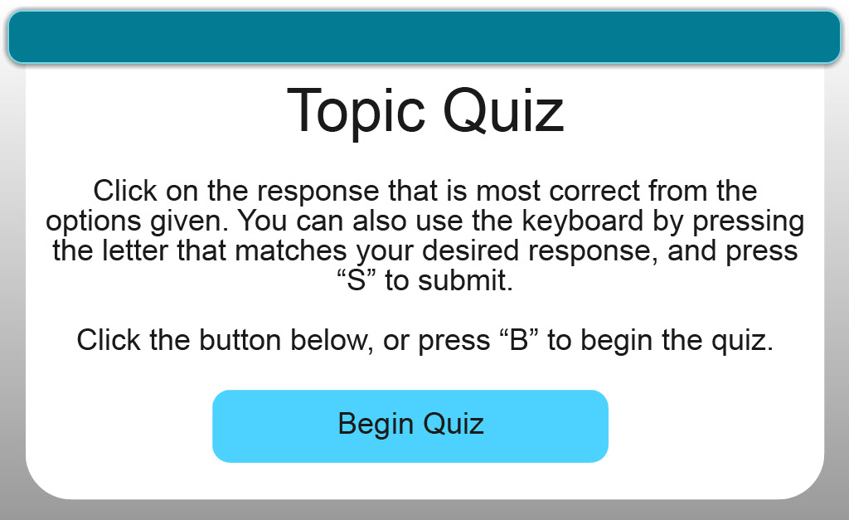
Slide notes
Text Captions

Topic Quiz

Begin Quiz

Quiz Question 1 – Multiple Choice 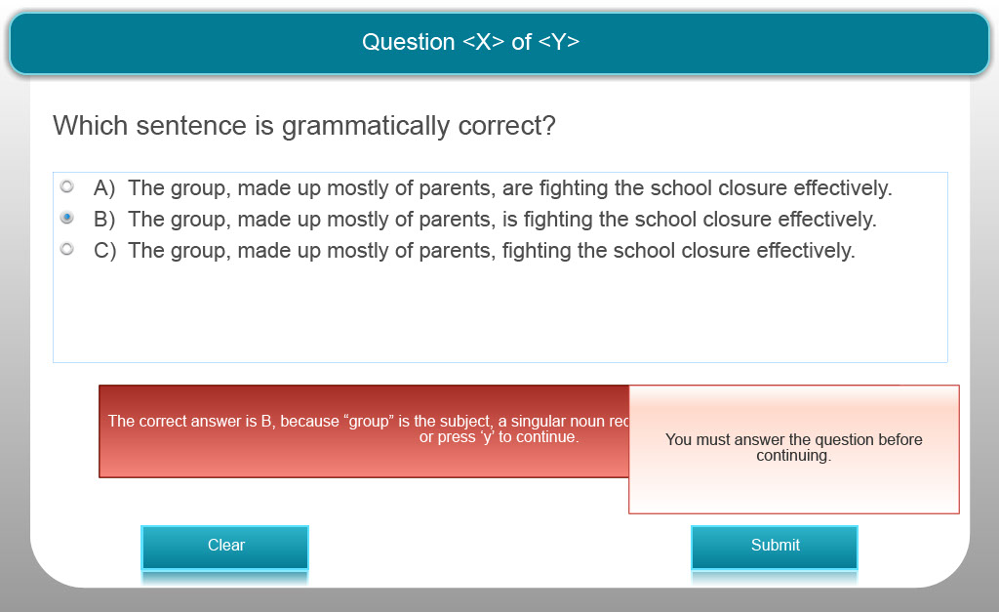
Slide notes
Text Captions

Which sentence is grammatically correct?

A) The group, made up mostly of parents, are fighting the school closure effectively.

B) The group, made up mostly of parents, is fighting the school closure effectively.

C) The group, made up mostly of parents, fighting the school closure effectively.

The correct answer is B, because “group” is the subject, a singular noun requiring a singular verb.

Quiz Question 2 – Multiple Choice
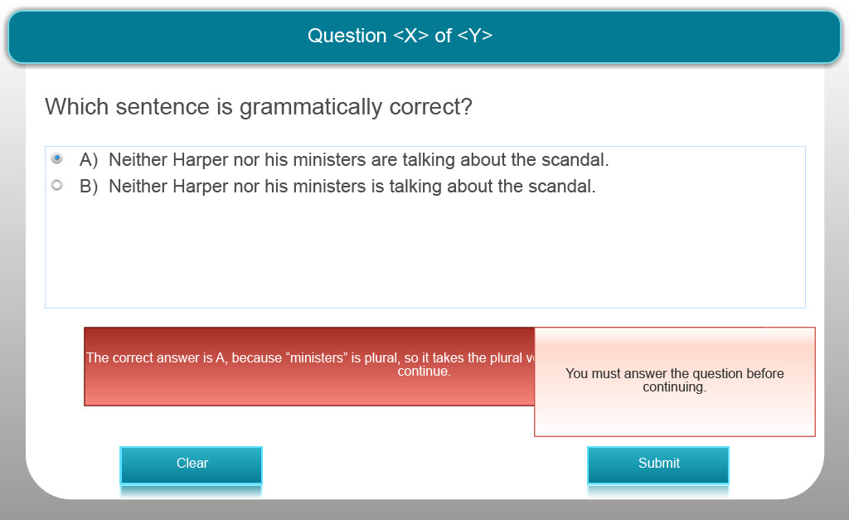
Slide notes
Text Captions

Which sentence is grammatically correct?

A) Neither Harper nor his ministers are talking about the scandal.

B) Neither Harper nor his ministers is talking about the scandal.

The correct answer is A, because “ministers” is plural, so it takes the plural verb “are.”

Quiz Question 3 – Multiple Choice
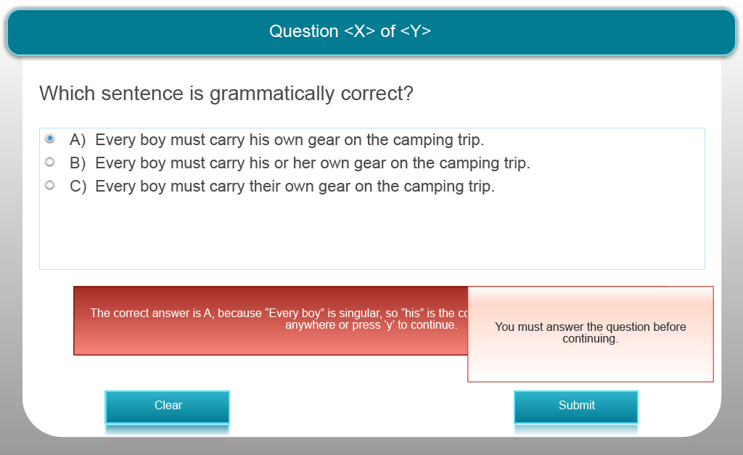
Slide notes
Text Captions

Which sentence is grammatically correct?

A) Every boy must carry his own gear on the camping trip.

B) Every boy must carry his or her own gear on the camping trip.

C) Every boy must carry their own gear on the camping trip.

The correct answer is A, because “Every boy” is singular, so “his” is the corresponding singular pronoun.

Quiz Question 4 – Multiple Choice
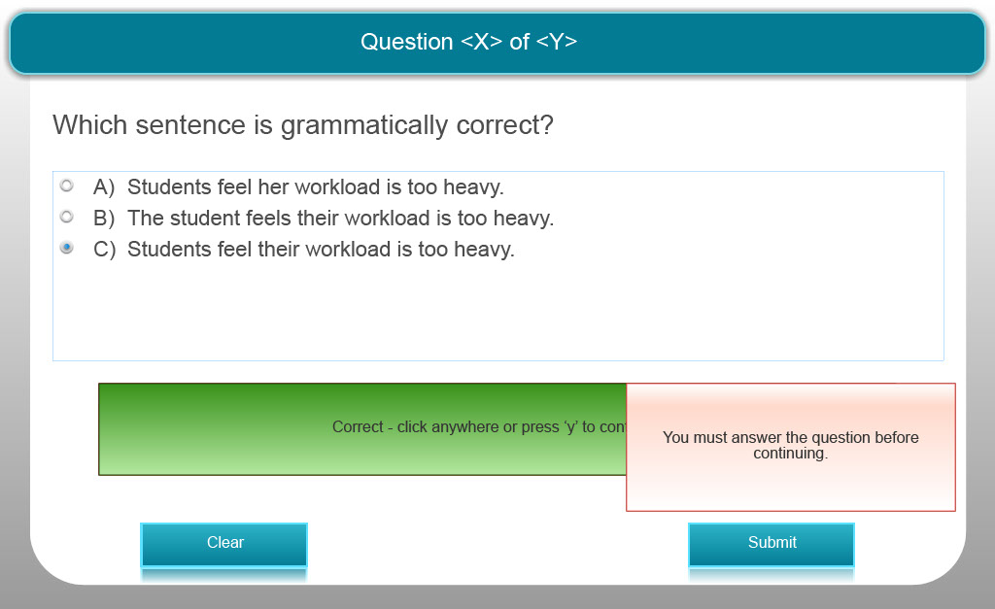
Slide notes
Text Captions

Which sentence is grammatically correct?

A) Students feel her workload is too heavy.
B) The student feels their workload is too heavy.
C) Students feel their workload is too heavy.

The correct answer is C, because “Students” is plural, so “their” is the corresponding plural pronoun.

Quiz Question 5 – Multiple Choice 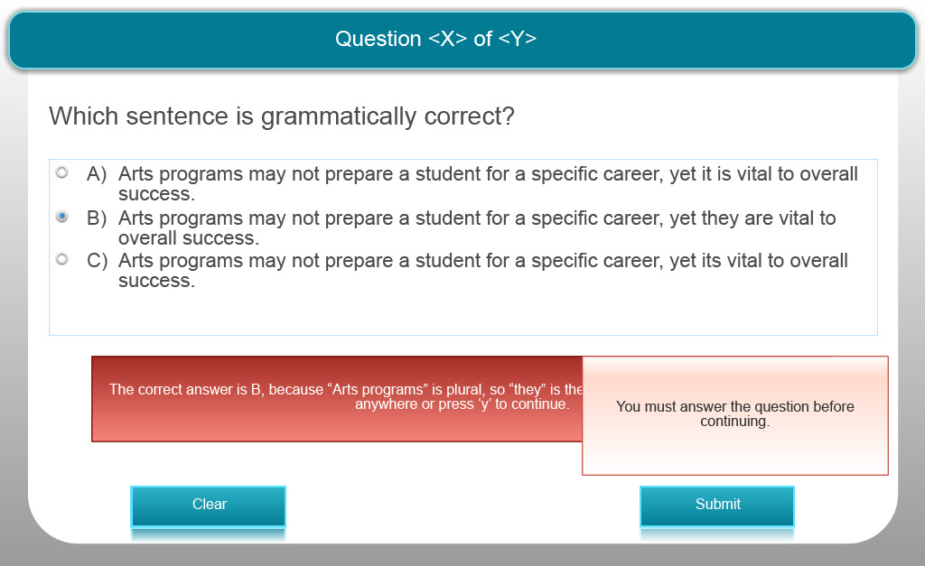
Slide notes
Text Captions

Which sentence is grammatically correct?

A) Arts programs may not prepare a student for a specific career, yet it is vital to overall success.

B) Arts programs may not prepare a student for a specific career, yet they are vital to overall success.

C) Arts programs may not prepare a student for a specific career, yet its vital to overall success.

The correct answer is B, because “Arts programs” is plural, so “they” is the corresponding plural pronoun.

Quiz Question 6 – Multiple Choice
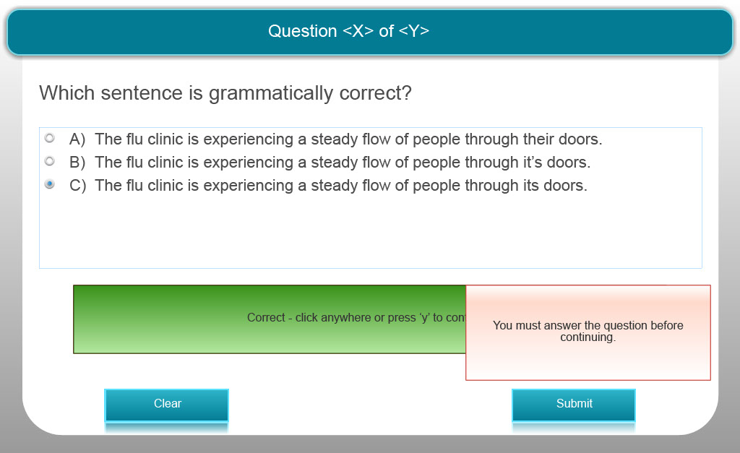
Slide notes
Text Captions

Which sentence is grammatically correct?

A) The flu clinic is experiencing a steady flow of people through their doors.

B) The flu clinic is experiencing a steady flow of people through it’s doors.

C) The flu clinic is experiencing a steady flow of people through its doors.

The correct answer is C, because “flu clinic” is singular, so “its” is the corresponding singular pronoun.

Quiz Question 7 – Multiple Choice
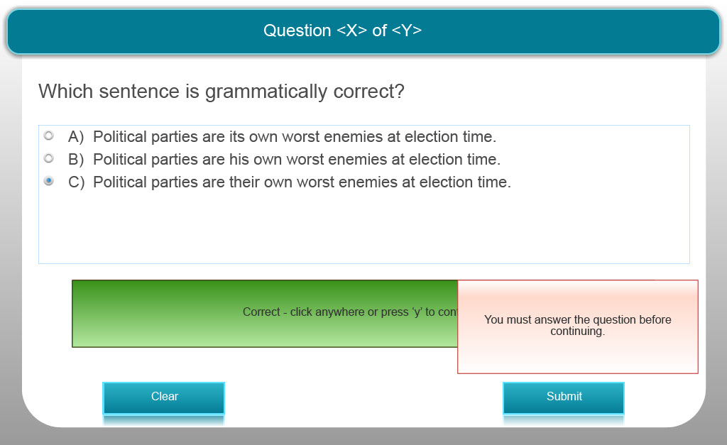
Slide notes
Text Captions

Which sentence is grammatically correct?

A) Political parties are its own worst enemies at election time.

B) Political parties are his own worst enemies at election time.

C) Political parties are their own worst enemies at election time.
The correct answer is C, because “Political parties” is plural, so “their” is the corresponding plural pronoun.

Quiz Question 8 – Multiple Choice
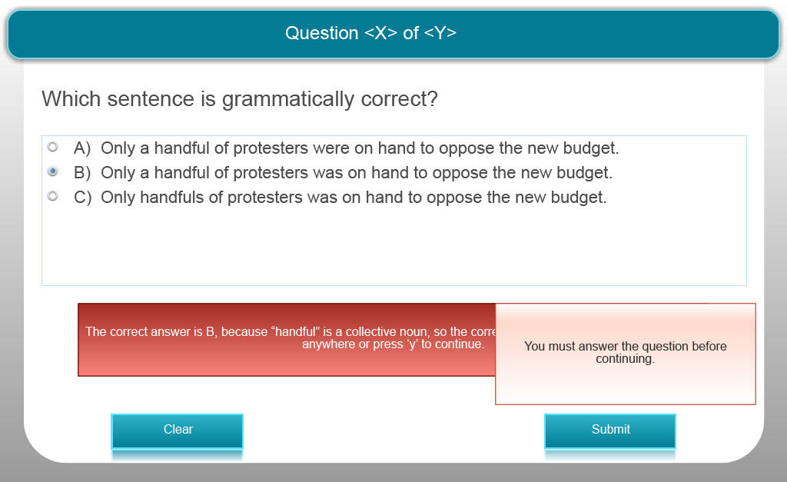
Slide notes
Text Captions

Which sentence is grammatically correct?

A) Only a handful of protesters were on hand to oppose the new budget.

B) Only a handful of protesters was on hand to oppose the new budget.

C) Only handfuls of protesters was on hand to oppose the new budget.
The correct answer is B, because “handful” is a collective noun, so the corresponding singular verb is “was.”

Quiz Question 9 – Multiple Choice
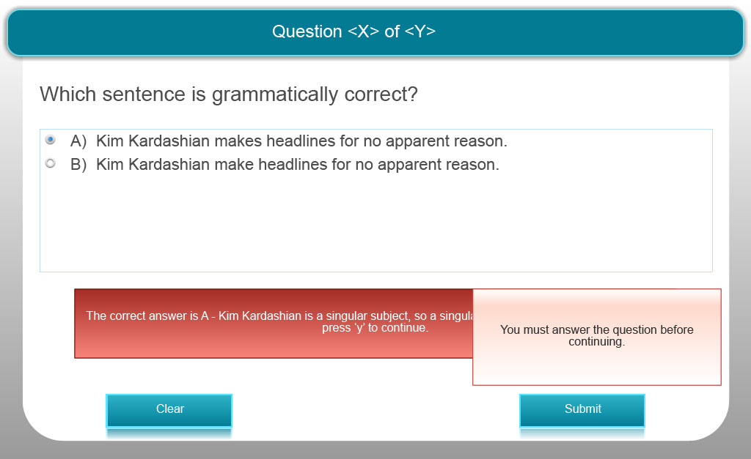
Slide notes
Text Captions

Which sentence is grammatically correct?

A) Kim Kardashian makes headlines for no apparent reason.

B) Kim Kardashian make headlines for no apparent reason.

The correct answer is A - Kim Kardashian is a singular subject, so a singular verb is required.

Quiz Question 10 – Multiple Choice
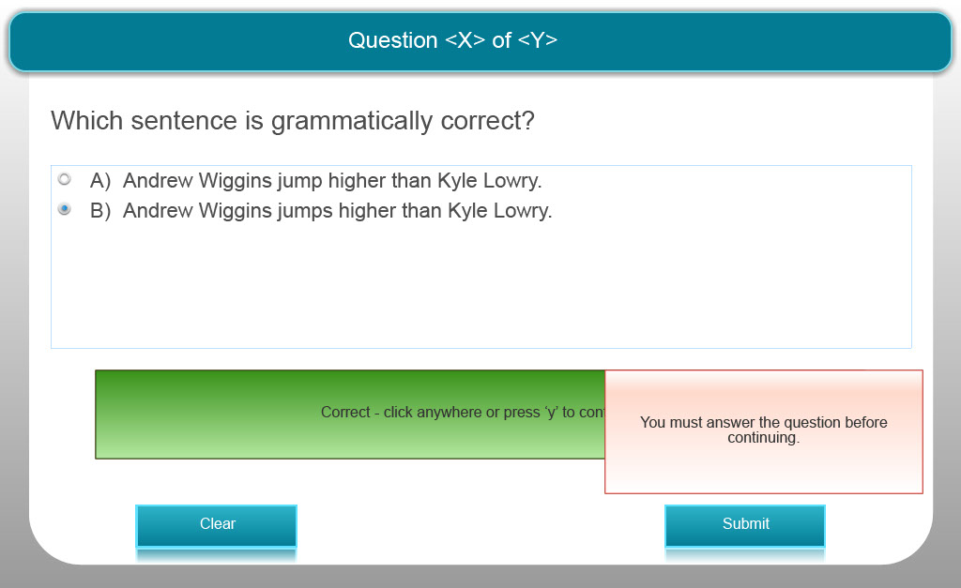
Slide notes
Text Captions

Which sentence is grammatically correct?

A) Andrew Wiggins jump higher than Kyle Lowry.

B) Andrew Wiggins jumps higher than Kyle Lowry.

The correct answer is B - Andrew Wiggins is a singular subject, so a singular verb is required.

Quiz Question 11 – Multiple Choice
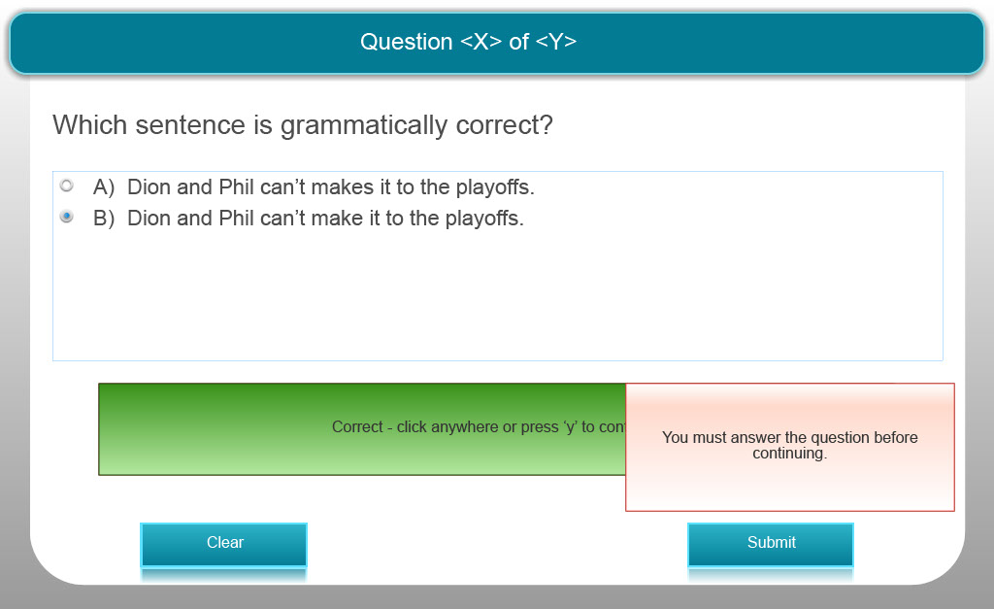
Slide notes
Text Captions

Which sentence is grammatically correct?

A) Dion and Phil can’t makes it to the playoffs.

B) Dion and Phil can’t make it to the playoffs.

The correct answer is B - Dion and Phil are two people, so a plural verb is required.

Quiz Question 12 – Multiple Choice
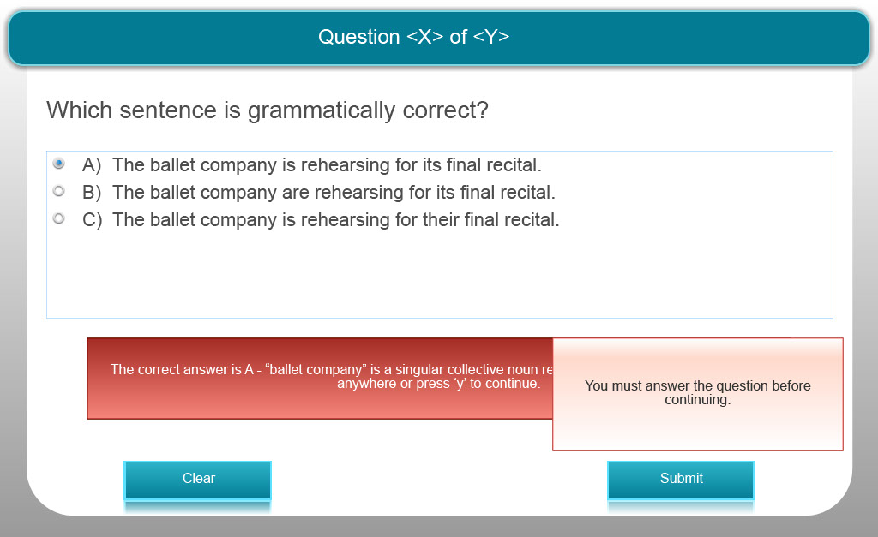
Slide notes
Text Captions

Which sentence is grammatically correct?

A) The ballet company is rehearsing for its final recital.

B) The ballet company are rehearsing for its final recital.

C) The ballet company is rehearsing for their final recital.

The correct answer is A - ballet company is a singular collective noun requiring a singular possessive.

Quiz Question 13 – Multiple Choice
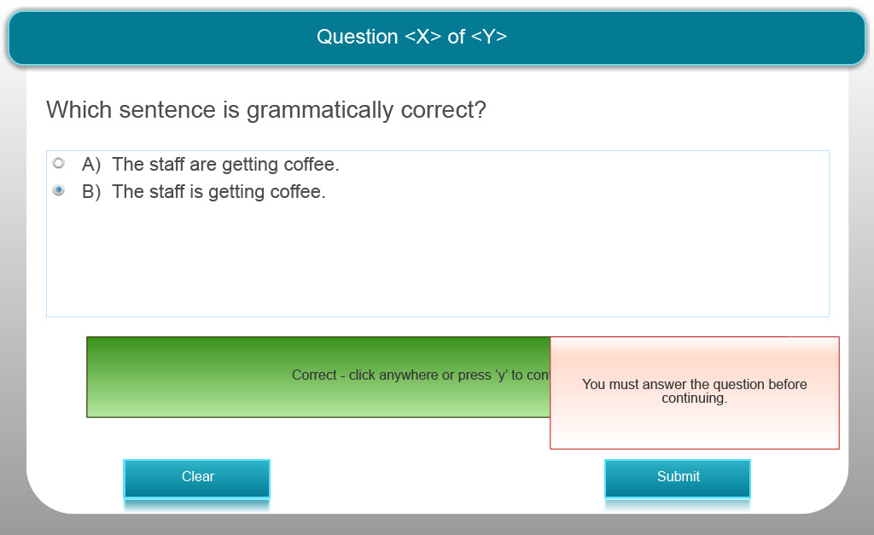
Slide notes
Text Captions

Which sentence is grammatically correct?

A) The staff are getting coffee.

B) The staff is getting coffee.

The correct answer is B - staff is a singular collective noun and requires a singular verb.

Quiz Question 14 – Multiple Choice
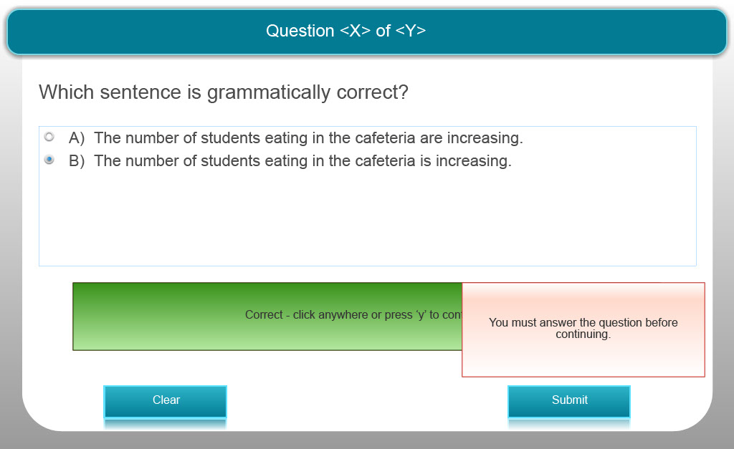
Slide notes
Text Captions

Which sentence is grammatically correct?

A) The number of students eating in the cafeteria are increasing.

B) The number of students eating in the cafeteria is increasing.

The correct answer is B - as number is singular and requires a singular verb.

Quiz Question 15 – Multiple Choice
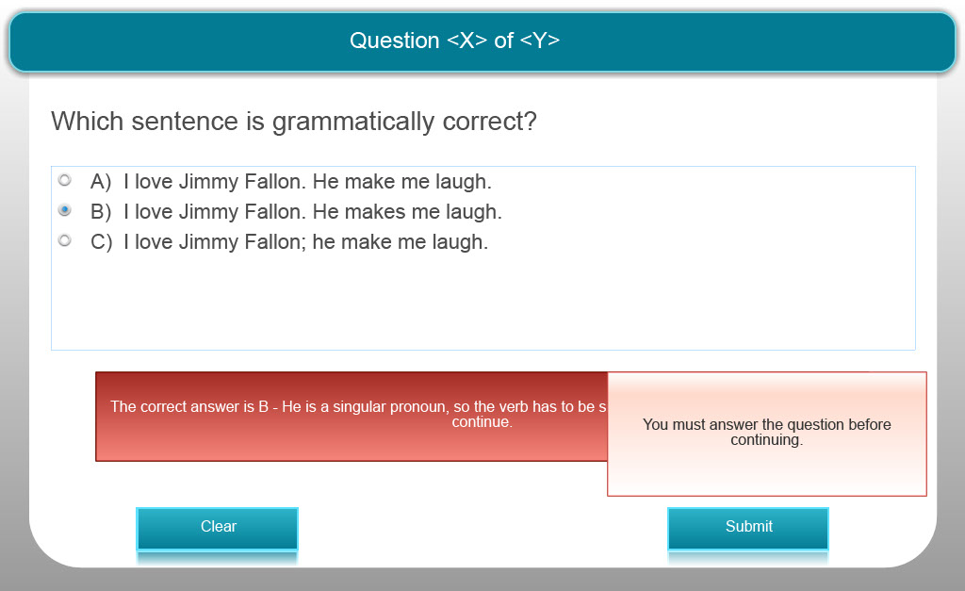
Slide notes
Text Captions

Which sentence is grammatically correct?

A) I love Jimmy Fallon. He make me laugh.

B) I love Jimmy Fallon. He makes me laugh.

C) I love Jimmy Fallon; he make me laugh.

The correct answer is B - He is a singular pronoun, so the verb has to be singular. ”In which sentence is the use of the pronoun unclear?

Quiz Question 16 – Multiple Choice
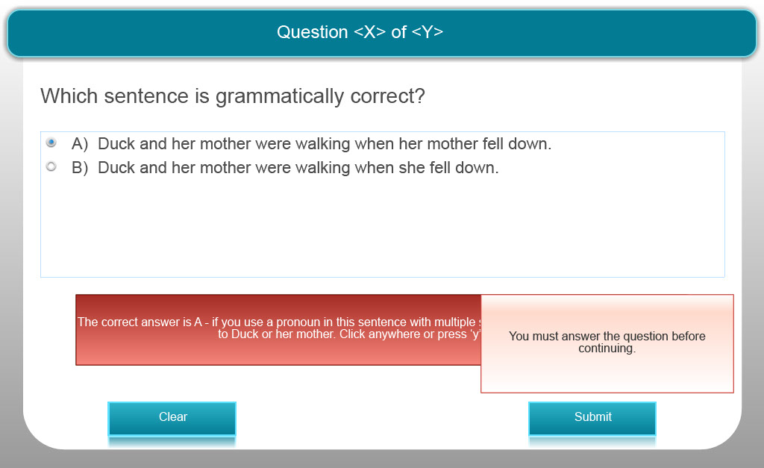
Slide notes
Text Captions

Which sentence is grammatically correct?

A) Duck and her mother were walking when her mother fell down.

B) Duck and her mother were walking when she fell down.

The correct answer is A - if you use a pronoun in this sentence with multiple subjects it is unclear if you are referring to Duck or her mother.

Slide 28 - Congratulations!

Slide notes
Text Captions

You have now completed Grammar and Syntax Module 3: Making Sentences Agreeable. You may now print a certificate of completion you should keep for your records.Please enter your name into the space below so we can personalize your certificate.

Congratulations!

Your name:

Slide 29 - Certificate of Completion
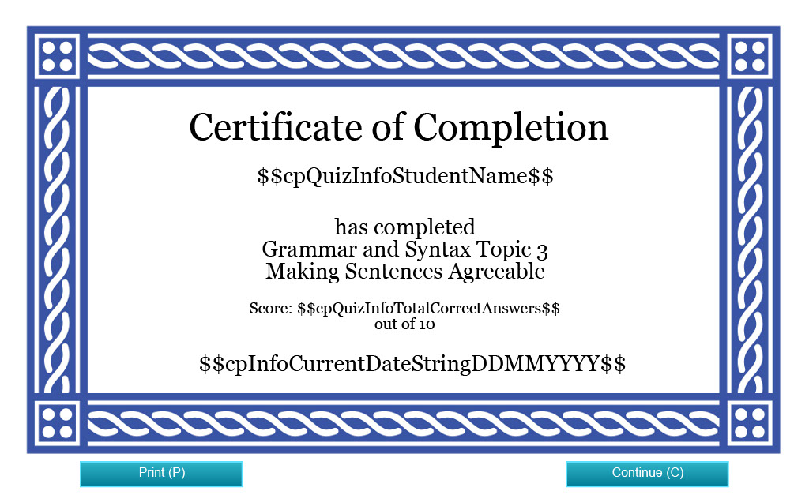
Slide notes
Text Captions

Certificate of Completion

has completed
Grammar and Syntax Topic 3
Making Sentences Agreeable

Slide 30 - Credits

Slide notes
Text Captions

Credits

Funding for this project was provided by the Ministry of Training, Colleges and Universities (MTCU) 2014-2015 Shared Online Course Fund.

Slide 31 - Credits
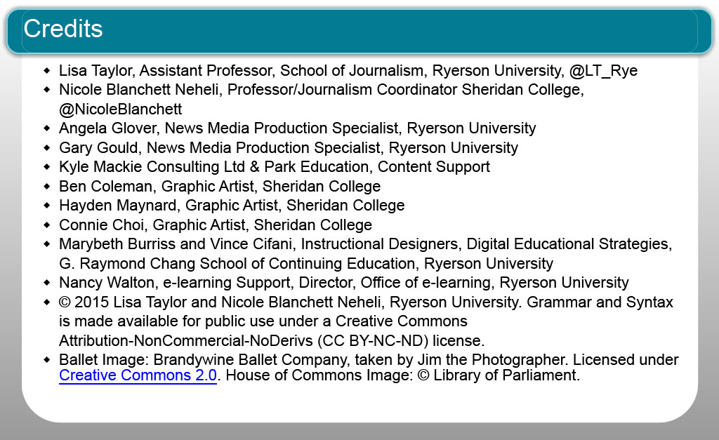
Slide notes
Text Captions

Lisa Taylor, Assistant Professor, School of Journalism, Ryerson University, @LT_Rye
Nicole Blanchett Neheli, Professor/Journalism Coordinator Sheridan College, @NicoleBlanchett
Angela Glover, News Media Production Specialist, Ryerson University
Gary Gould, News Media Production Specialist, Ryerson University
Kyle Mackie Consulting Ltd & Park Education, Content Support
Ben Coleman, Graphic Artist, Sheridan College
Hayden Maynard, Graphic Artist, Sheridan College
Connie Choi, Graphic Artist, Sheridan College
Marybeth Burriss and Vince Cifani, Instructional Designers, Digital Educational Strategies, G. Raymond Chang School of Continuing Education, Ryerson University
Nancy Walton, e-learning Support, Director, Office of e-learning, Ryerson University
© 2015 Lisa Taylor and Nicole Blanchett Neheli, Ryerson University. Grammar and Syntax is made available for public use under a Creative Commons Attribution-NonCommercial-NoDerivs (CC BY-NC-ND) license.
Ballet Image: Brandywine Ballet Company, taken by Jim the Photographer. Licensed under Creative Commons 2.0. House of Commons Image: © Library of Parliament.

Credits

