Slide 1 - Part 1
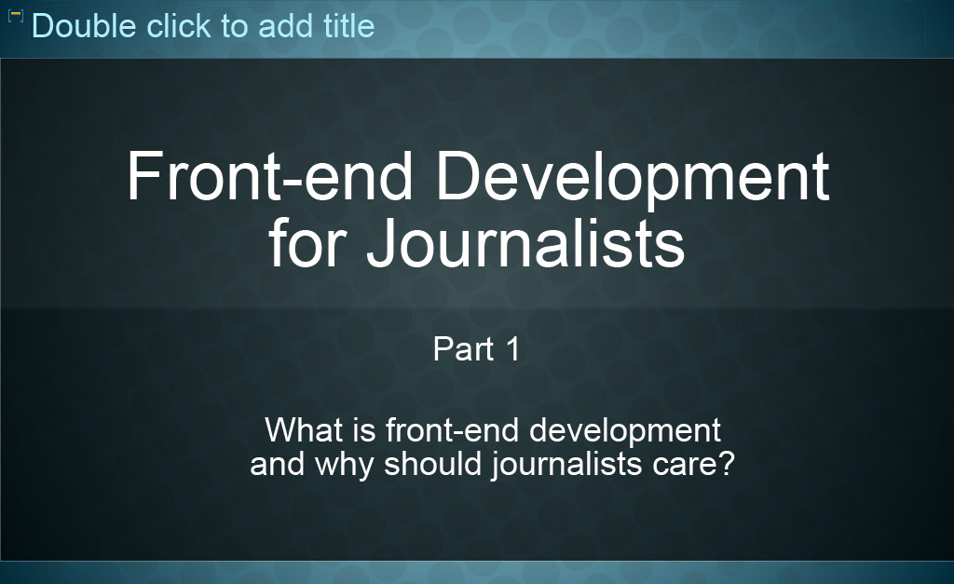
Slide notes
Welcome to part 1 of Front-end development for journalists.
In this module, you'll learn the basics
of what front-end web development is, and why journalists should care.
Additionally, you will learn about some of the building blocks of the web, HTML and CSS.
This means you'll be able to think about what is possible or what is not possible when creating content for the web. This will help you create web content that is well designed, and it will provide you with basic vocabulary for talking to front-end developers about how to lay out your content.

[Slides 2 and 3 have been are omitted for this text-based alternative]

Slide 4 - What is Front-end Development?
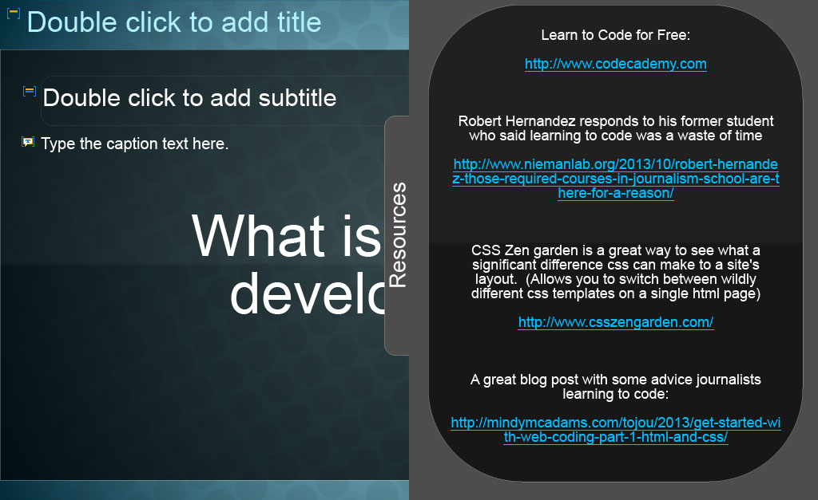
Slide notes
Front-end development is the work that makes a website look the way it does.
It determines the layout, colours, font-sizes, and interactivity of a website.
By front-end, we mean the part of the website facing the user – that’s why it's called front-end development, because this is the front end of the website that the user can see.

Text Captions
Resources
Learn to Code for Free
Robert Hernandez responds to his former student who said learning to code was a waste of time
CSS Zen garden is a great way to see what a significant difference css can make to a site's layout. (Allows you to switch between wildly different css templates on a single html page)
A great blog post with some advice journalists learning to code:

Slide 5 - Why Front-end Development?
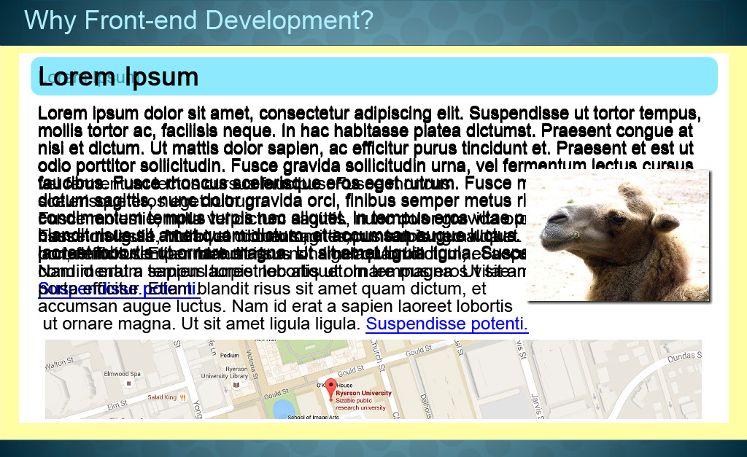
Slide notes
Without front-end web development, all websites would look like plain text.
Black text on a white background, and not much else.
Good front-end development can make web content easier to navigate, can draw attention to important information, and can support interactivity.
Front-end developers make web content easier to read and more engaging.
For example they can add:
Headings, Paragraphs, Links, Images, Layout elements, Colours Shadows and interactive elements like polls or maps.

Text Captions
Why Front-end Development?

Slide 6 - Why Should Journalists Care?
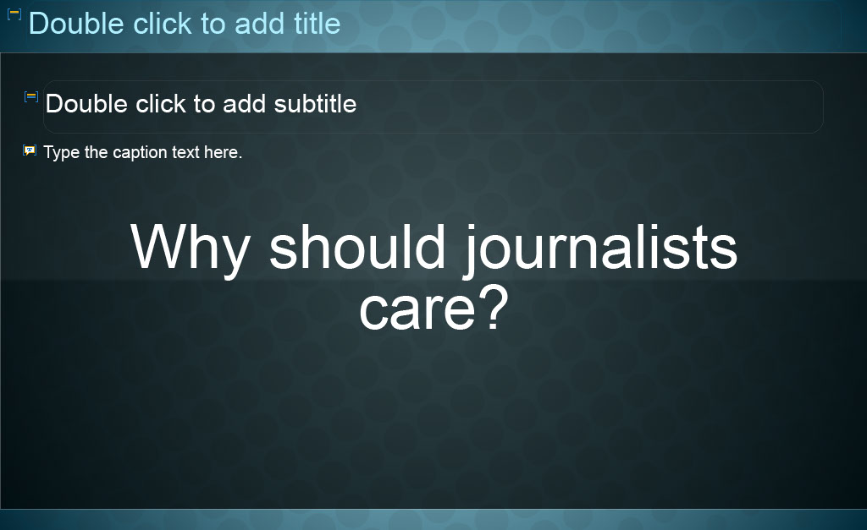
Slide notes
Why should journalists care about web development?
Some journalism students dread learning to make websites, and would prefer to spend that time honing other skills.
But the reality is that learning a few basics can go a long way.

Text Captions
Why should journalists care?

Slide 7 - Online Media
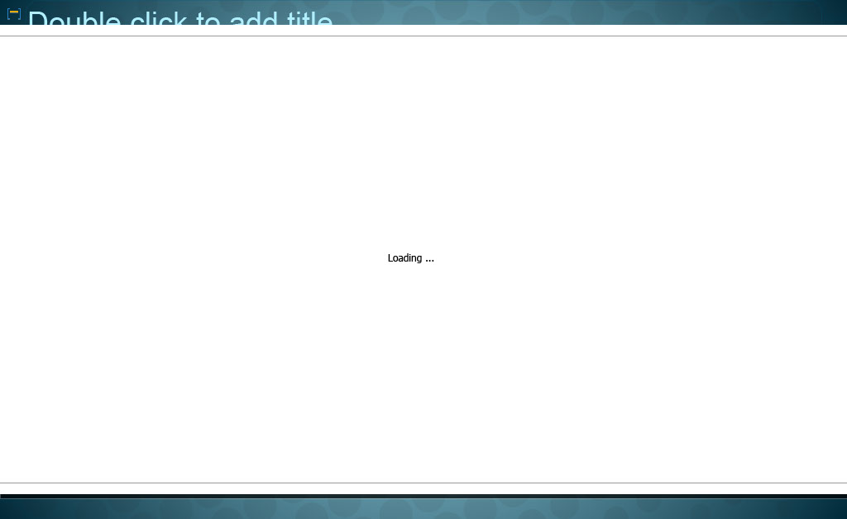
Slide notes
More and more media has moved online, and this means that almost all journalists will end up producing at least some web content.
Does every journalism student need to become a master developer?
Absolutely not. But understanding basic elements of how the web works can go a long way.

Slide 8 - Understanding the Basics
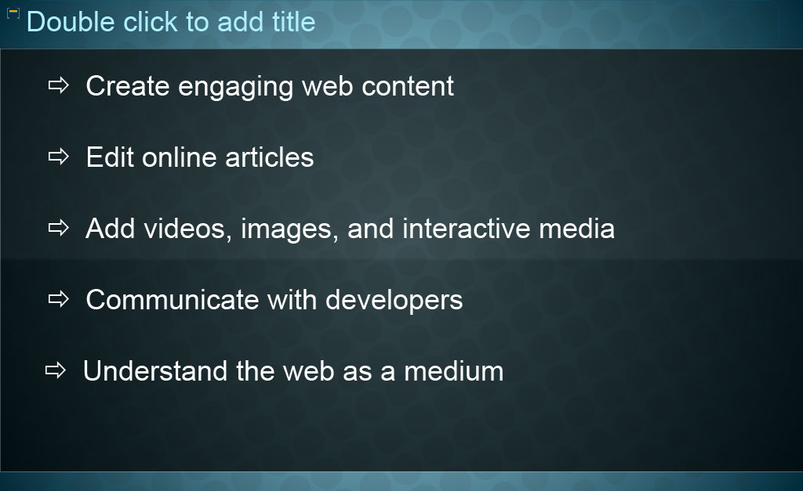
Slide notes
If you understand some basics about front-end development,
it will help you: create articles that are more engaging, attractive, and accessible to readers; edit online articles – including fixing formatting and other errors; add videos, images, and interactive media to those articles; clearly communicate to developers about how articles should work and look; and generally understand the capabilities and limitations of the web as a medium.

Text Captions
Create engaging web content
Edit online articles
Add videos, images, and interactive media
Communicate with developers
Understand the web as a medium

Slide 9 - HTML and CSS
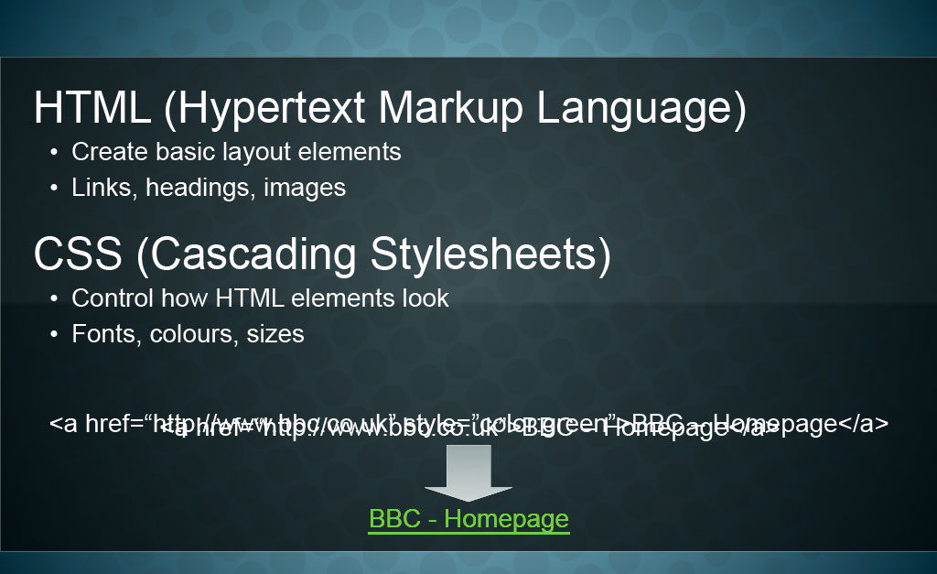
Slide notes
To learn about front-end development, it's important to familiarize yourself with two types of code: HTML and CSS. HTML, which stands for Hypertext Markup Language, is used to create basic elements of a website. For example, links, images, headings and other basic elements are created using HTML. For example, the HTML code displayed below will create a link to the BBC's website. CSS, which stands for Cascading Styles Sheets, is used to control the appearance of those elements. For example, if HTML is used to create a link, CSS can be used to change the colour, size, or other stylistic aspects of that link.
Text Captions
Two Types of Code: HTML and CSS
HTML (Hypertext Markup Language)
- Create basic layout elements
- Links, headings, images
<a href=“http://www.bbc.co.uk”>BBC – Homepage</a>
BBC - Homepage
CSS (Cascading Stylesheets)
- Control how HTML elements look
- Fonts, colours, sizes
<a href=“http://www.bbc.co.uk” style=”color:green”>BBC – Homepage</a>
BBC - Homepage

Slide 10 - Responsive Design
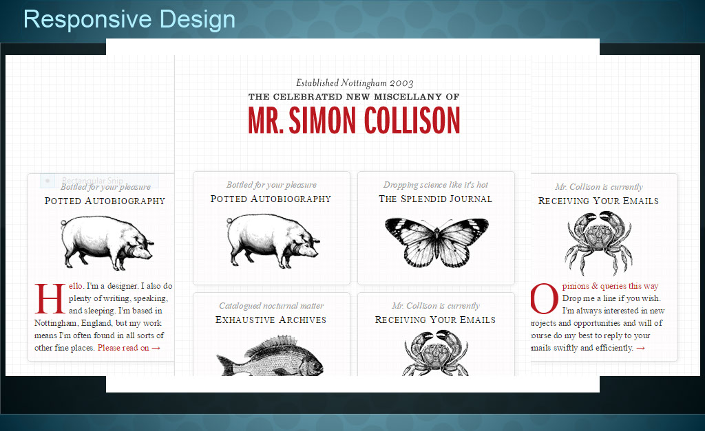
Slide notes
Good front-end development is becoming more and more important as journalism moves to new types of digital devices.
Particularly, mobile devices mean that many websites need to look good on multiple types of screens.
A site that looks great on a computer monitor may look bad on the smaller screen of a phone.
When thinking about how an article or other online features should look, other online feature should look, good developers consider multiple screen sizes. This is called responsive design. Responsive design can be somewhat complex to code, so it's better to get the basics down first. But anyone making content for the web should at least make sure their work can be appreciated on both desktop and mobile devices.
Text Captions
Responsive Design
Consider multiple screen sizes

Slide 11 - Slide 11
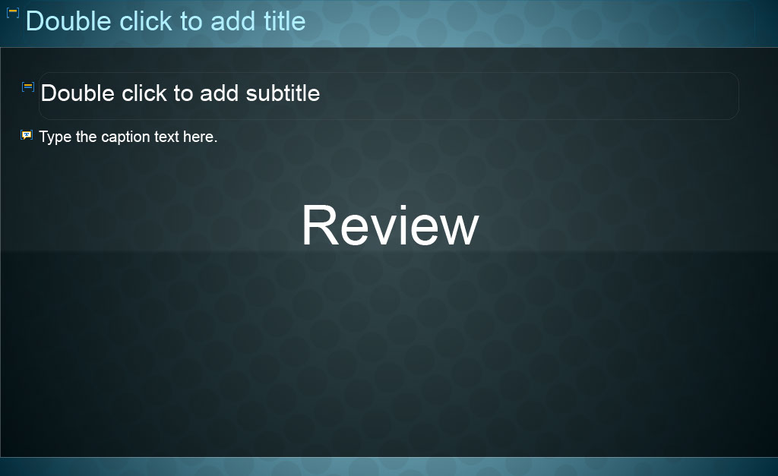
Slide notes
Let's review what we've learned by considering a few questions.
On the next slides read the question, think about the answer, then click 'Reveal Answer' to check if you were right.

Text Captions

Review

Slide 12 - Slide 12
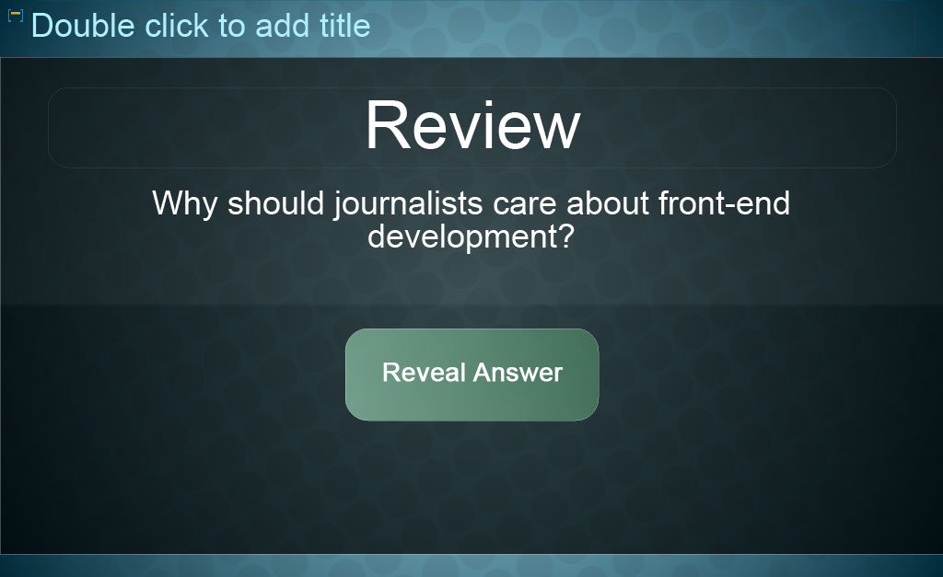
Slide notes
Text Captions

Review

Why should journalists care about front-end development?

Reveal Answer

Slide 13 - Slide 13
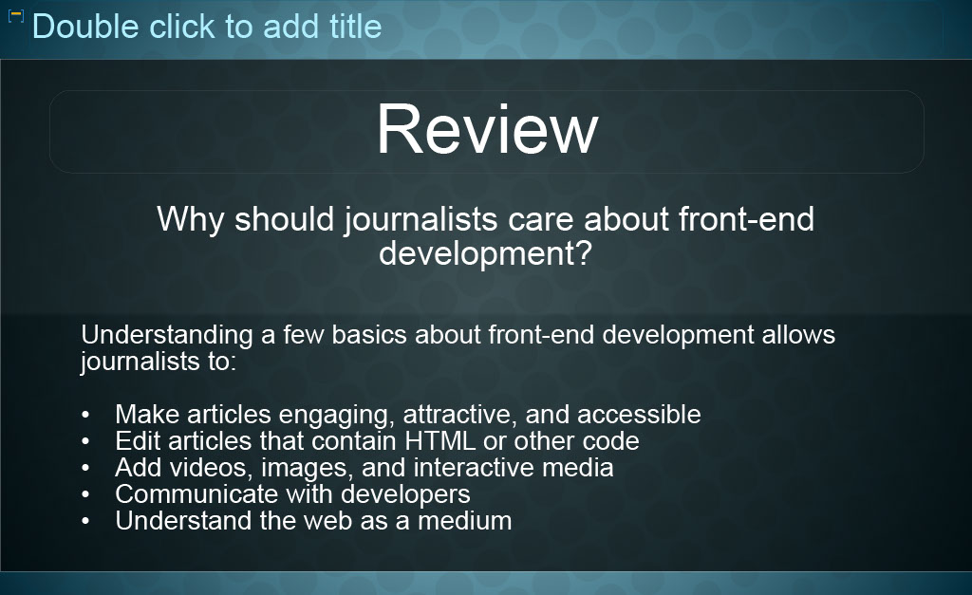
Slide notes
Text Captions

Review
Why should journalists care about front-end development?

Understanding a few basics about front-end development allows journalists to:
- Make articles engaging, attractive, and accessible
- Edit articles that contain HTML or other code
- Add videos, images, and interactive media
- Communicate with developers
- Understand the web as a medium

Slide 14 - Slide 14
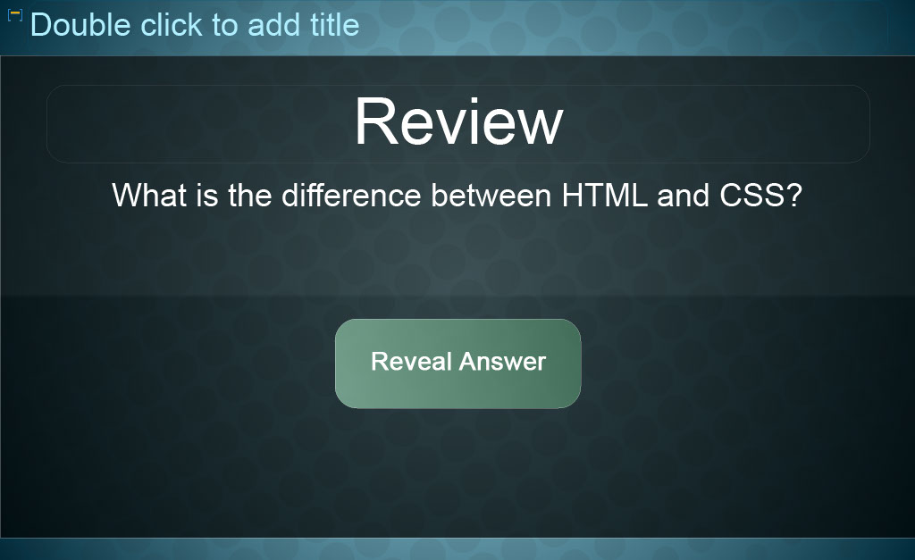
Slide notes
Text Captions

Review

What is the difference between HTML and CSS?

Reveal Answer

Slide 15 - Slide 15
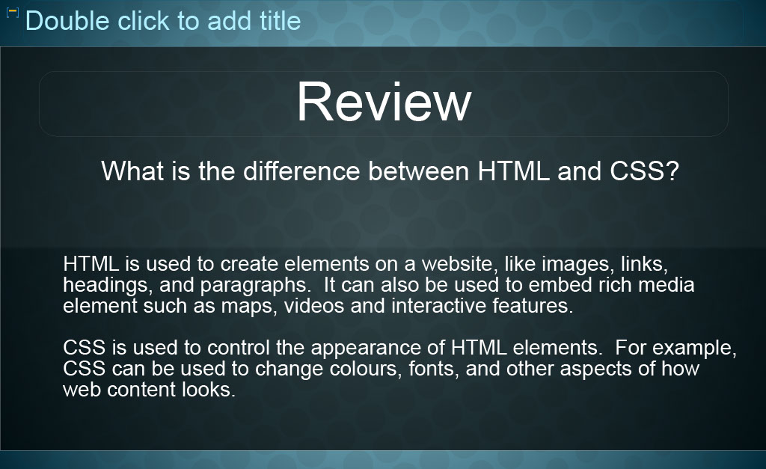
Slide notes
Text Captions

Review
What is the difference between HTML and CSS?

HTML is used to create elements on a website, like images, links, headings, and paragraphs. It can also be used to embed rich media element such as maps, videos and interactive features.
CSS is used to control the appearance of HTML elements. For example, CSS can be used to change colours, fonts, and other aspects of how web content looks.

Slide 16 - Slide 16
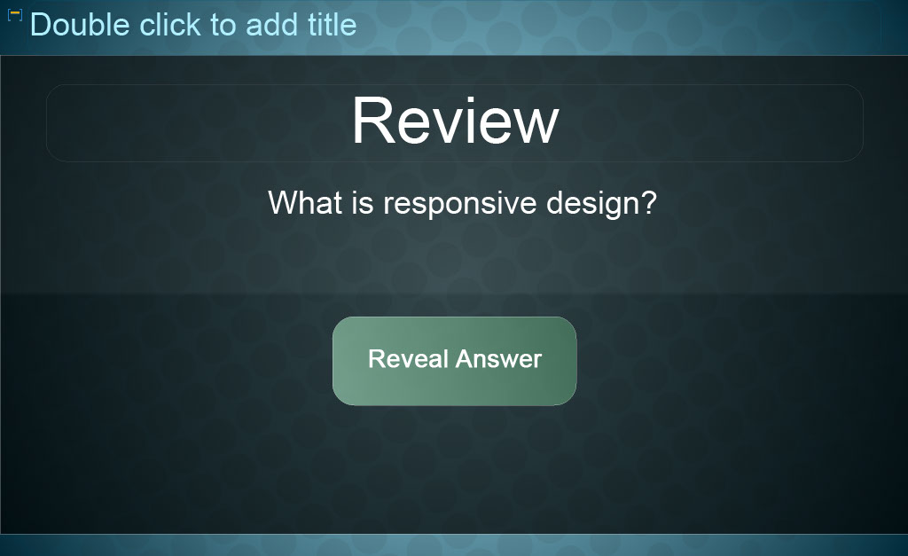
Slide notes
Text Captions

Review

Reveal Answer

What is responsive design?

Slide 17 - Slide 17
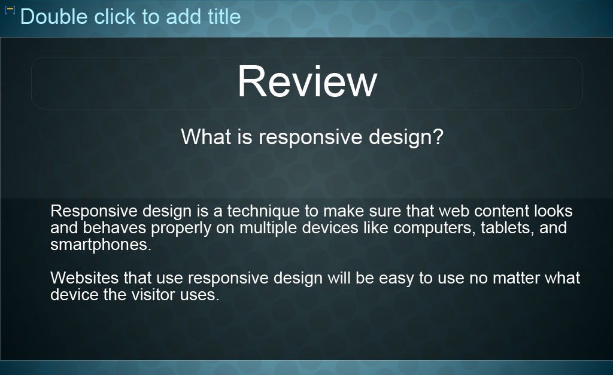
Slide notes
Text Captions

Review
What is responsive design?

Responsive design is a technique to make sure that web content looks and behaves properly on multiple devices like computers, tablets, and smartphones.

Websites that use responsive design will be easy to use no matter what device the visitor uses.

Slide 18 - Good Work!
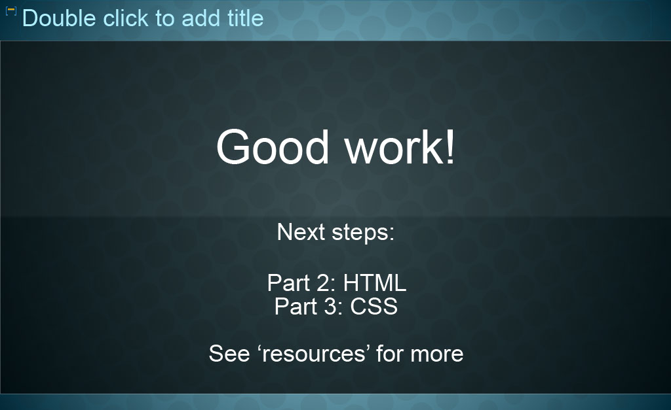
Slide notes
Good work on completing Part 1 of Front-end Development for Journalists. In Part 2, you'll learn some basic HTML, and in Part 3 you'll learn some basic CSS. That will enable you to read basic HTML and CSS, and write some of your own code. After those lessons, if you want to learn to code interactivity, JavaScript is a good choice. It is recommended you learn the basics of HTML and CSS before studying JavaScript. A good place to start is with Code Academy’s free online course. To access the Code Academy course please see the link under 'Resources'. Welcome to part 1 of Front-end development for journalists.

Text Captions
Good work! Next steps:
Part 2: HTML
Part 3: CSS
See ‘resources’ for more

Slide 19 - Congratulations!
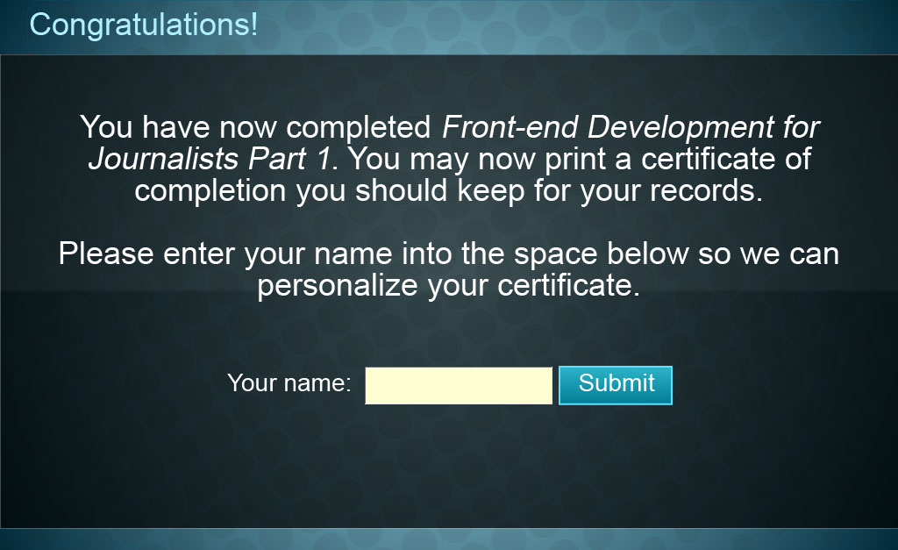
Slide notes
Text Captions

You have now completed Front-end Development for Journalists Part 1. You may now print a certificate of completion you should keep for your records.

Please enter your name into the space below so we can personalize your certificate.

Congratulations!

Your name:

Slide 20 - Certificate of Completion
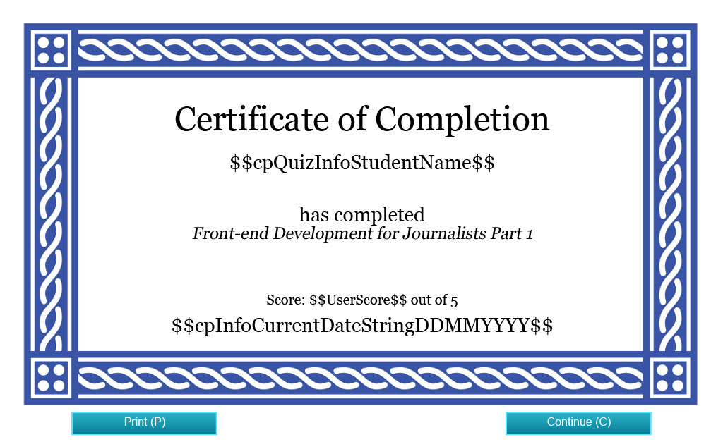
Slide notes
[Screenshot of a blank Certificate of Completion]

Slide 21 - Credits

Slide notes
Text Captions

Credits

Funding for this project was provided by the Ministry of Training, Colleges and Universities (MTCU) 2014-2015 Shared Online Course Fund.

Slide 22 - Credits
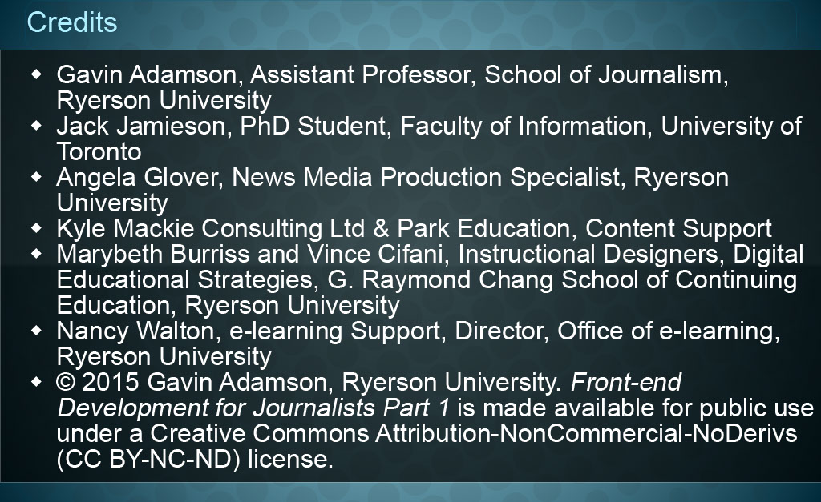
Slide notes
Text Captions
Credits
Gavin Adamson, Assistant Professor, School of Journalism, Ryerson University
Jack Jamieson, PhD Student, Faculty of Information, University of Toronto
Angela Glover, News Media Production Specialist, Ryerson University
Kyle Mackie Consulting Ltd & Park Education, Content Support
Marybeth Burriss and Vince Cifani, Instructional Designers, Digital Educational Strategies, G. Raymond Chang School of Continuing Education, Ryerson University
Nancy Walton, e-learning Support, Director, Office of e-learning, Ryerson University
© 2015 Gavin Adamson, Ryerson University. Front-end Development for Journalists Part 1 is made available for public use under a Creative Commons Attribution-NonCommercial-NoDerivs (CC BY-NC-ND) license.

