Slide 1 - Analytics Topic 4

Slide notes
Analytics for Journalists

Topic 4: Editorial Decision-making

[Slide 2 has been are omitted for this text-based alternative]

Slide 3 - Topic Video

Slide notes
Text Captions

Analytics for Journalists - Topic 4
Slide 4 - Learning Outcomes
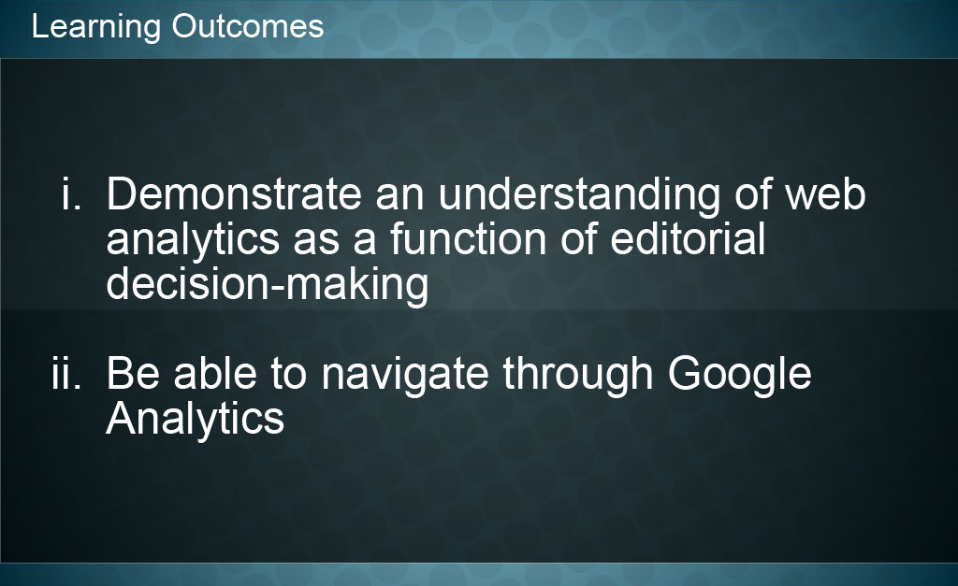
Slide notes
Now that you’ve finished this module you should be able to:
- Demonstrate an understanding of web analytics as a function of editorial decision-making, and you should
- be able to navigate through Google Analytics.

Slide 5 - Topic Quiz

Slide notes

Begin Quiz

Question 1 – Multiple Choice 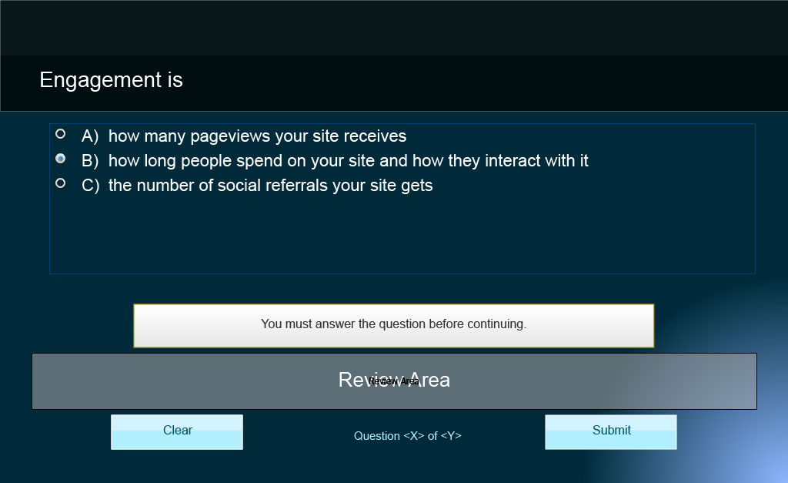
Slide notes

Engagement is

A) how many pageviews your site receives
B) how long people spend on your site and how they interact with it
C) the number of social referrals your site gets

Question 2 – True/False
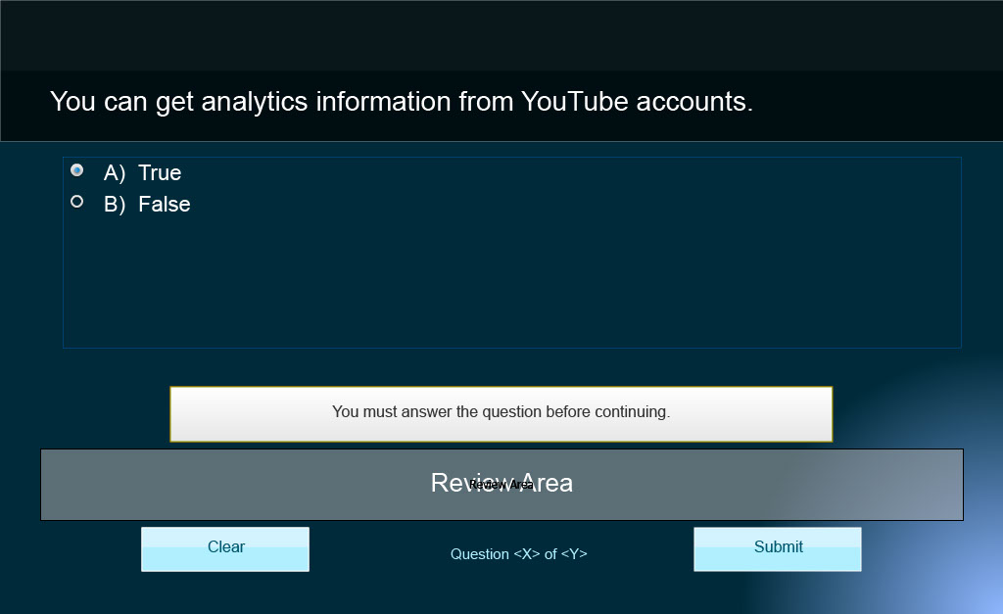
Slide notes

You can get analytics information from YouTube accounts.

A) True
B) False

Question 3 – Multiple Choice
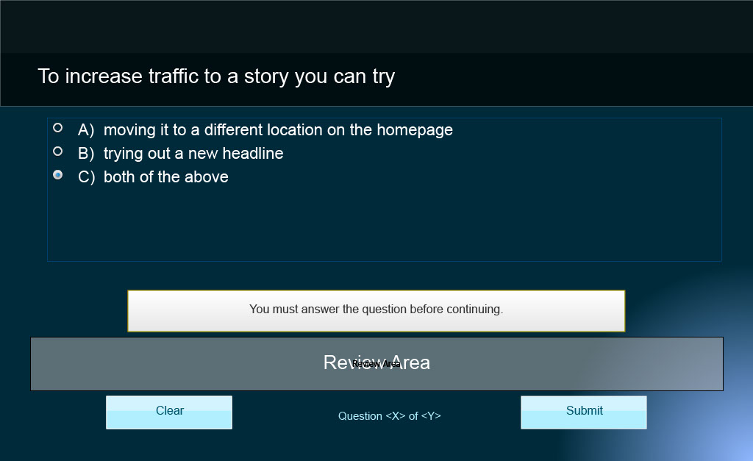
Slide notes

To increase traffic to a story you can try

A) moving it to a different location on the homepage
B) trying out a new headline
C) both of the above

Question 4 – True/False
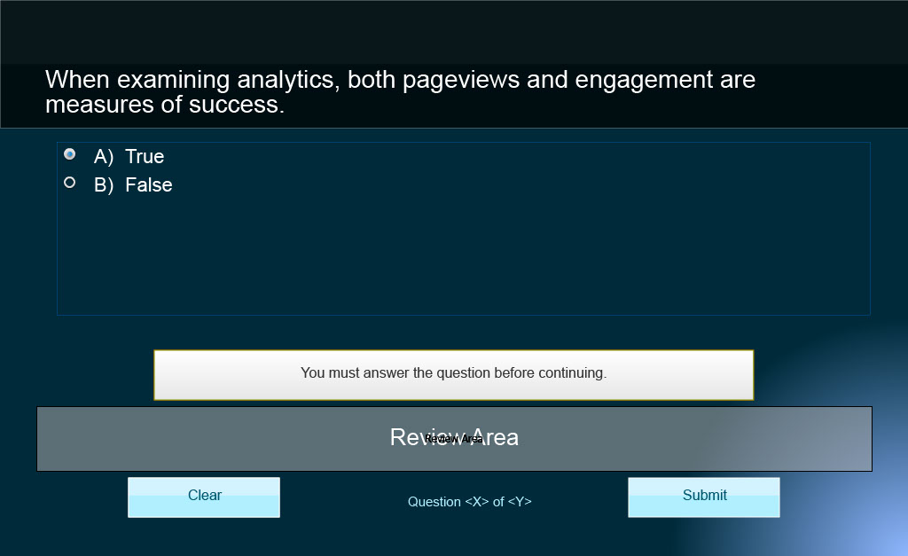
Slide notes

When examining analytics, both pageviews and engagement are measures of success.

A) True
B) False

Question 5 – True/False
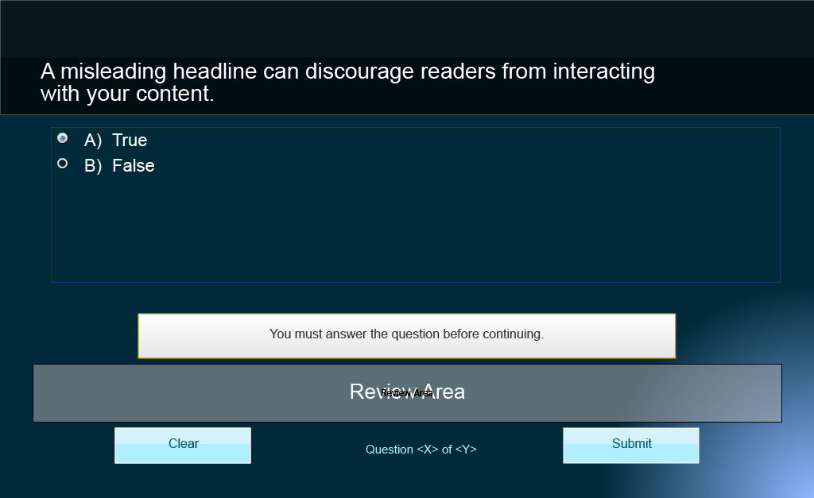
Slide notes
Text Captions

A misleading headline can discourage readers from interacting with your content.

A) True
B) False

Question 6 – True/False
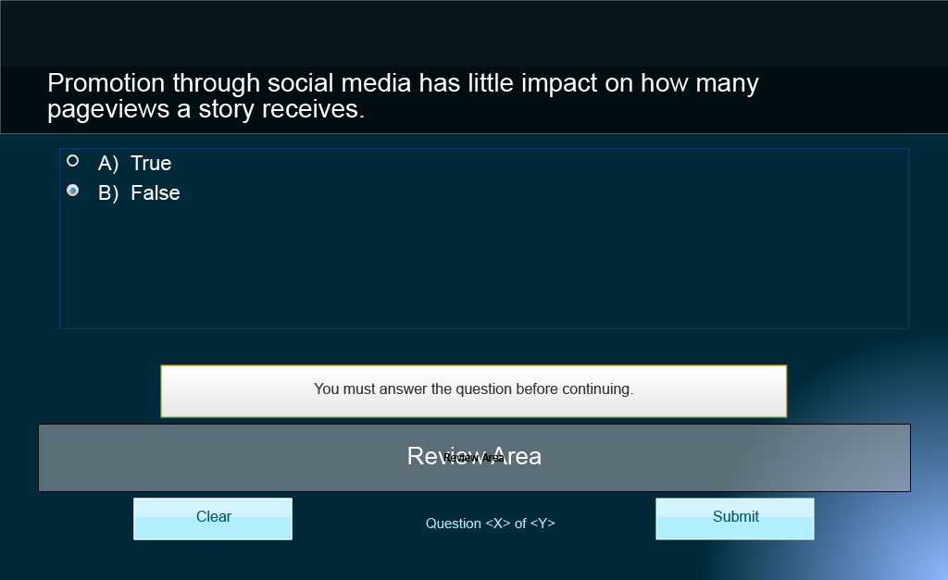
Slide notes
Text Captions

Promotion through social media has little impact on how many pageviews a story receives.

A) True
B) False

Question 7 – Multiple Choice
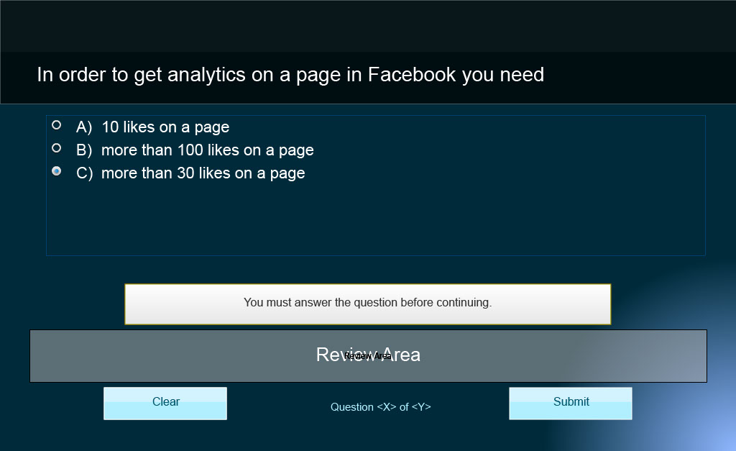
Slide notes

In order to get analytics on a page in Facebook you need

A) 10 likes on a page
B) more than 100 likes on a page
C) more than 30 likes on a page

Question 8 – Multiple Choice
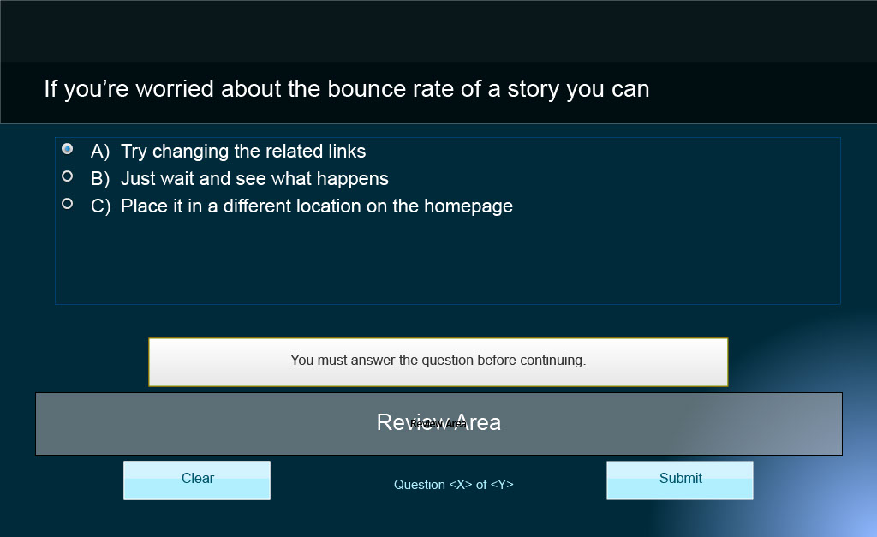
Slide notes

If you’re worried about the bounce rate of a story you can

A) Try changing the related links
B) Just wait and see what happens
C) Place it in a different location on the homepage

Question 9 – True/False
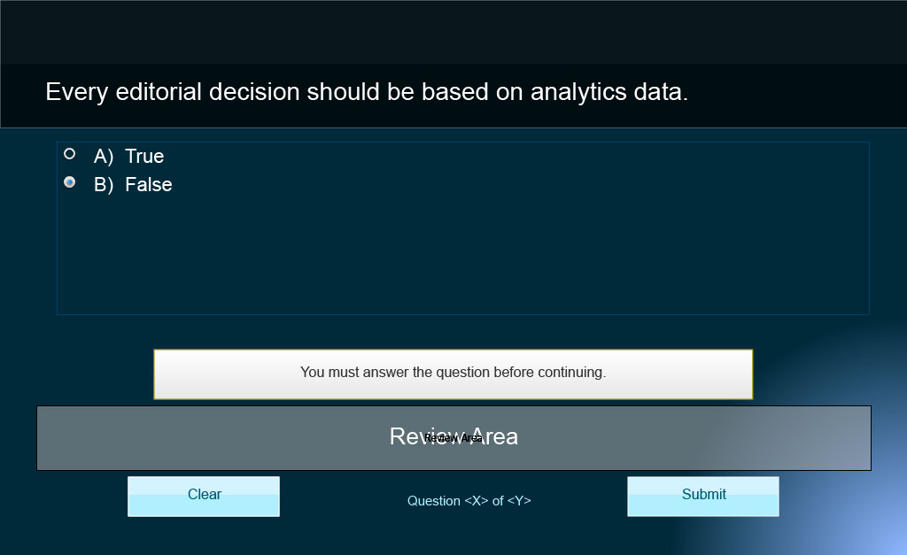
Slide notes

Every editorial decision should be based on analytics data.

A) True
B) False

Slide 17 - Congratulations!

Slide notes
You have now completed Analytics for Journalists Topic 3: Audience Behaviour. You may now print a certificate of completion you should keep for your records.

Please enter your name into the space below so we can personalize your certificate.

Congratulations!

Slide 18 - Certificate of Completion

Slide notes
[Screenshot of a blank Certificate of Completion]

Slide 19 - Credits

Slide notes
Credits

Funding for this project was provided by the Ministry of Training, Colleges and Universities (MTCU) 2014-2015 Shared Online Course Fund.

Slide 20 - Credits

Slide notes
Credits

Nicole Blanchett Neheli, Professor/Journalism Coordinator Sheridan College, B.A.A. Journalism, M.A. Professional Communication
Nikolas Clarke and Gregory Prince – Sheridan College technical support
Mitchell Varley – Editor
Kyle Mackie Consulting Ltd & Park Education, Content Support
Marybeth Burriss and Vince Cifani, Instructional Designers, Digital Educational Strategies, G. Raymond Chang School of Continuing Education, Ryerson University
Nancy Walton, e-learning Support, Director, Office of e-learning, Ryerson University
Funding for this project was provided by the Ministry of Training Colleges and Universities (MTCU) 2014-2015 Shared Online Course Fund
© 2015 Nicole Blanchett Neheli, Ryerson University. Web Analytics for Journalists is made available for public use under a Creative Commons Attribution-NonCommercial-NoDerivs (CC BY-NC-ND) license.

