Slide 1 - Analytics Topic 2

Slide notes
Analytics for Journalists

Topic 2: Audience Acquisiton

[Slide 2 has been are omitted for this text-based alternative]

Slide 3 - Topic Video

Slide notes
Watch the following video:

Analytics for Journalists - Topic 2

Slide 4 - Learning Outcomes
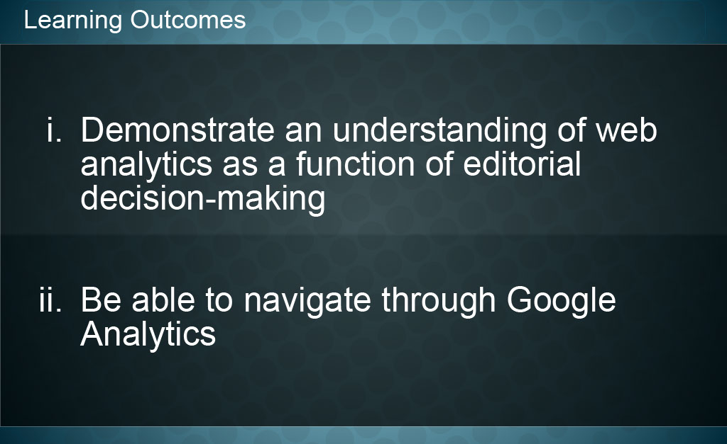
Slide notes
Now that you’ve finished this module you should be able to:
- Demonstrate an understanding of web analytics as a function of editorial decision-making, and you should
- be able to navigate through Google Analytics.

Slide 5 - Topic Quiz
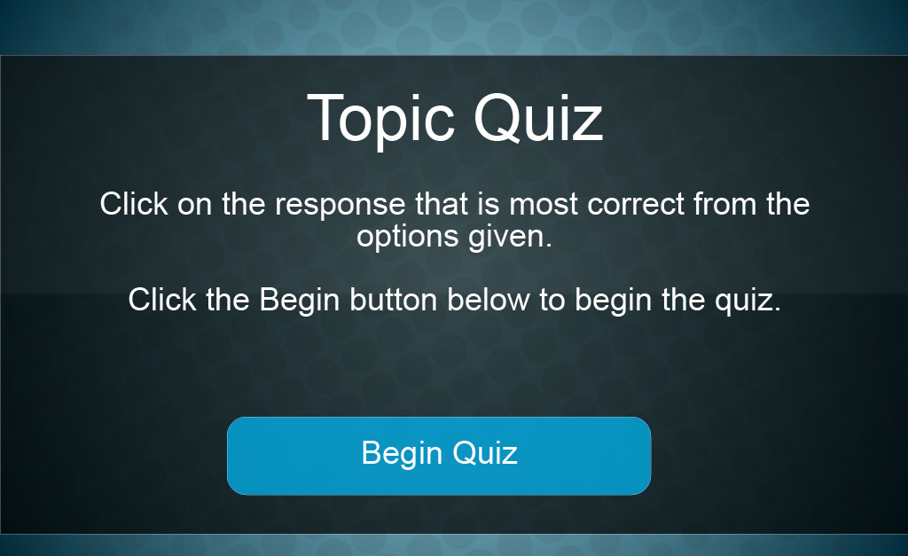
Slide notes
Text Captions

Begin Quiz

Question 1 - True/False
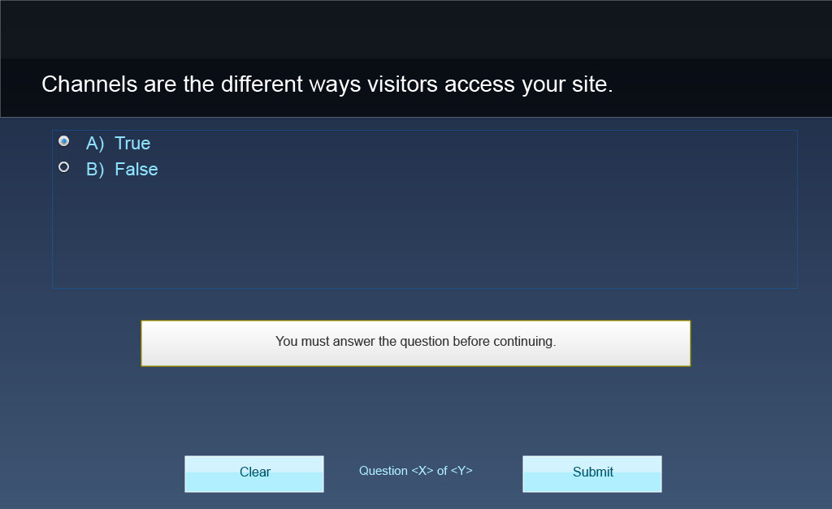
Slide notes
Text Captions

Channels are the different ways visitors access your site.

A) True
B) False

Question 2 - True/False 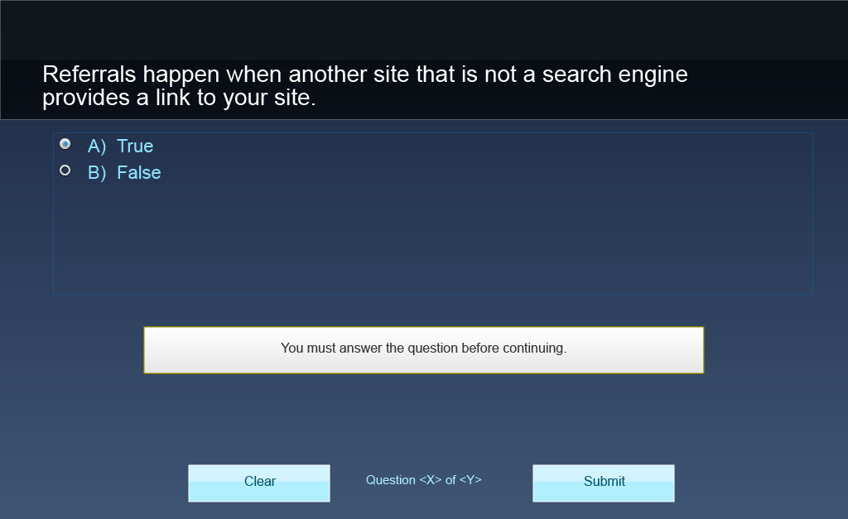
Slide notes
Text Captions

Referrals happen when another site that is not a search engine provides a link to your site.

A) True

B) False

Question 3 - True/False
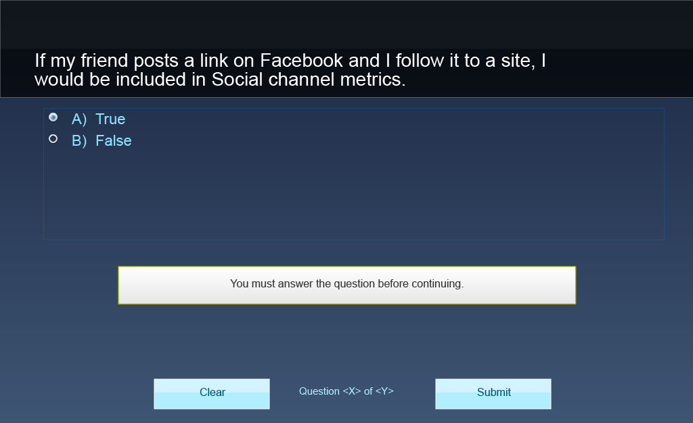
Slide notes
Text Captions

If my friend posts a link on Facebook and I follow it to a site, I would be included in Social channel metrics.

A) True

B) False

Question 4 - True/False 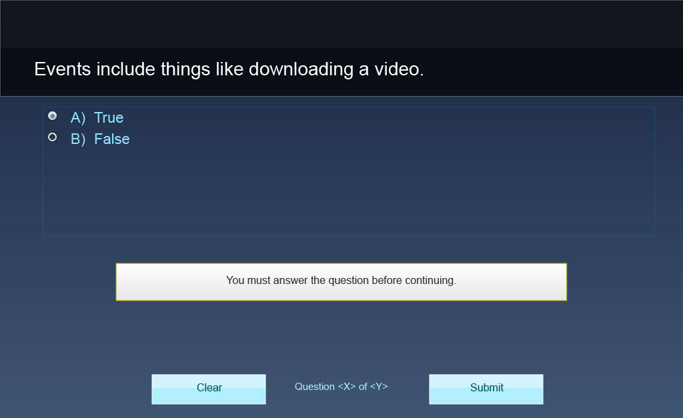
Slide notes
Text Captions

Events include things like downloading a video.

A) True

B) False

Question 5 - True/False 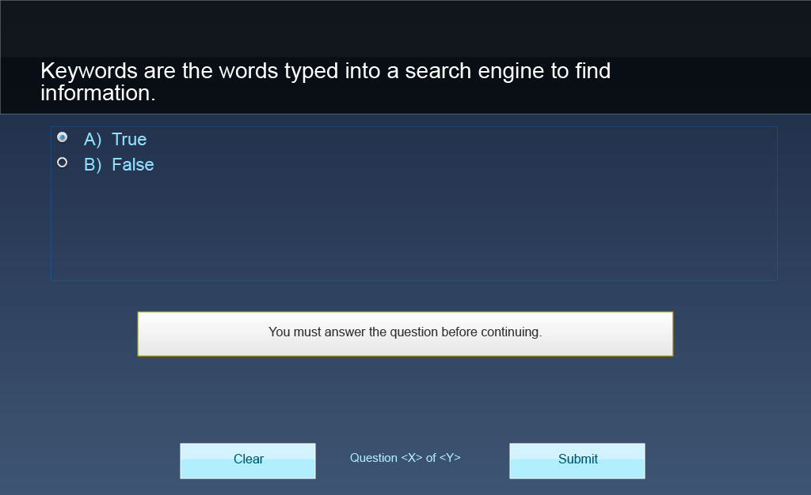
Slide notes
Text Captions

Keywords are the words typed into a search engine to find information.

A) True

B) False

Question 6 - True/False 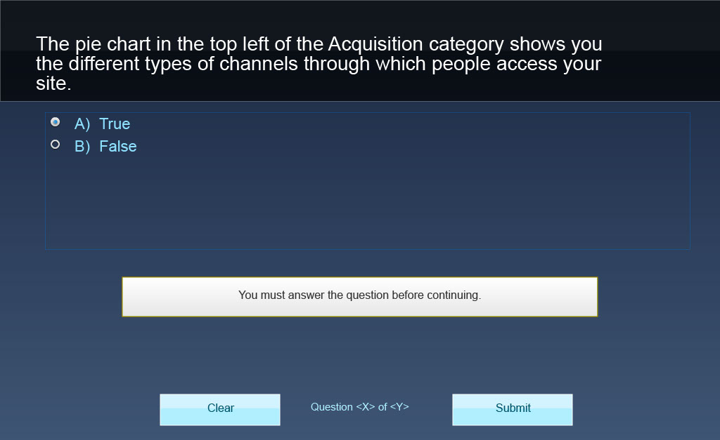
Slide notes
Text Captions

The pie chart in the top left of the Acquisition category shows you the different types of channels through which people access your site.

A) True

B) False

Question 7 - True/False 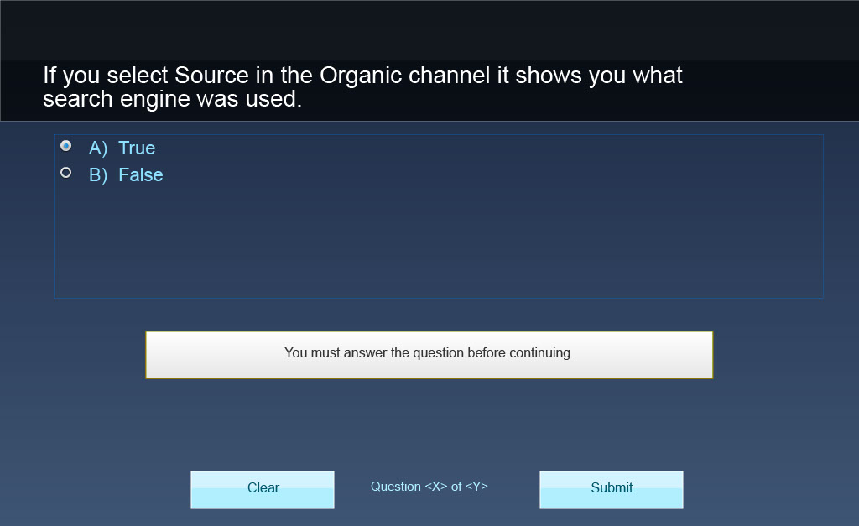
Slide notes
Text Captions

If you select Source in the Organic channel it shows you what search engine was used.

A) True

B) False

Question 8 – Multiple Choice 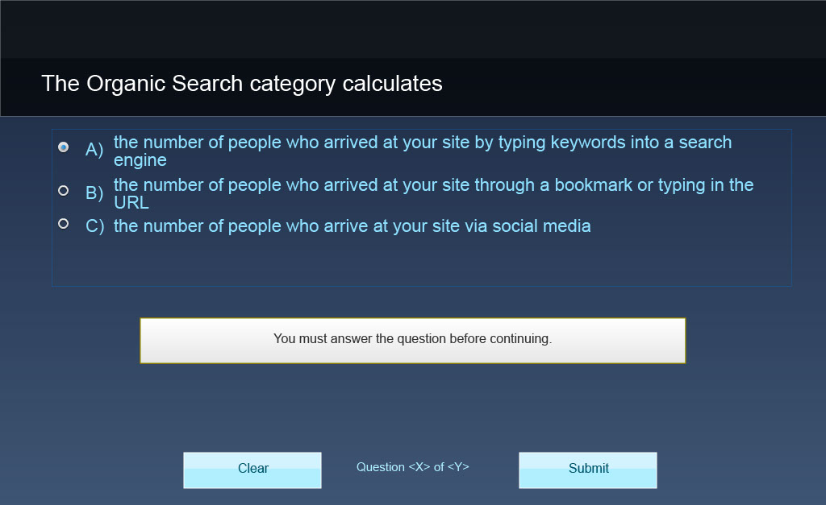
Slide notes
Text Captions

The Organic Search category calculates

A) the number of people who arrived at your site by typing keywords into a search engine
B) the number of people who arrived at your site through a bookmark or typing in the URL
C) the number of people who arrive at your site via social media

Question 9 – Multiple Choice
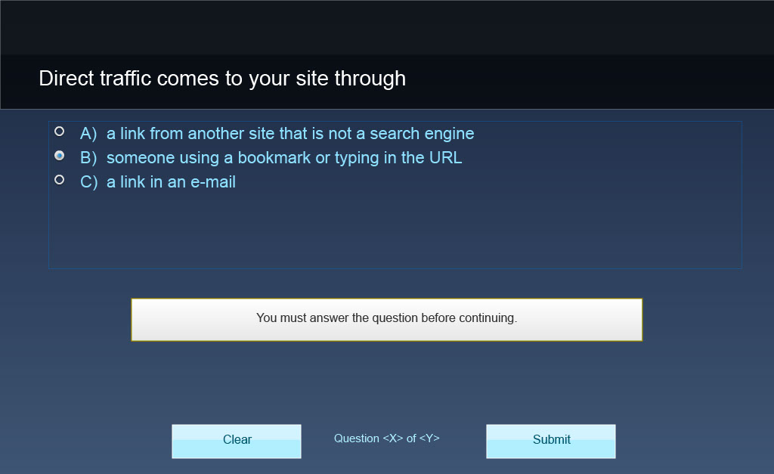
Slide notes
Text Captions

Direct traffic comes to your site through

A) a link from another site that is not a search engine
B) someone using a bookmark or typing in the URL
C) a link in an e-mail

Question 10 – Multiple Choice 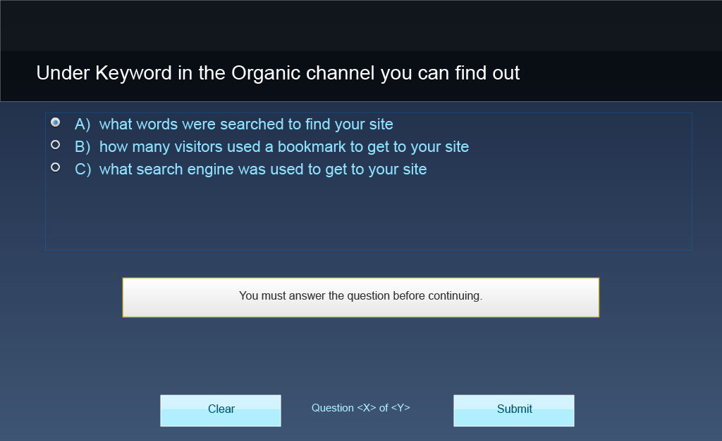
Slide notes
Text Captions

Under Keyword in the Organic channel you can find out

A) what words were searched to find your site
B) how many visitors used a bookmark to get to your site
C) what search engine was used to get to your site

Question 11 – Multiple Choice
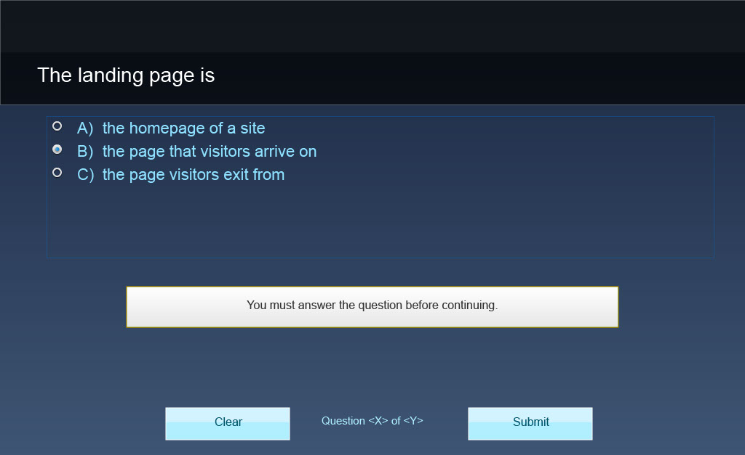
Slide notes
Text Captions

The landing page is

A) the homepage of a site
B) the page that visitors arrive on
C) the page visitors exit from

Question 12 – Multiple Choice
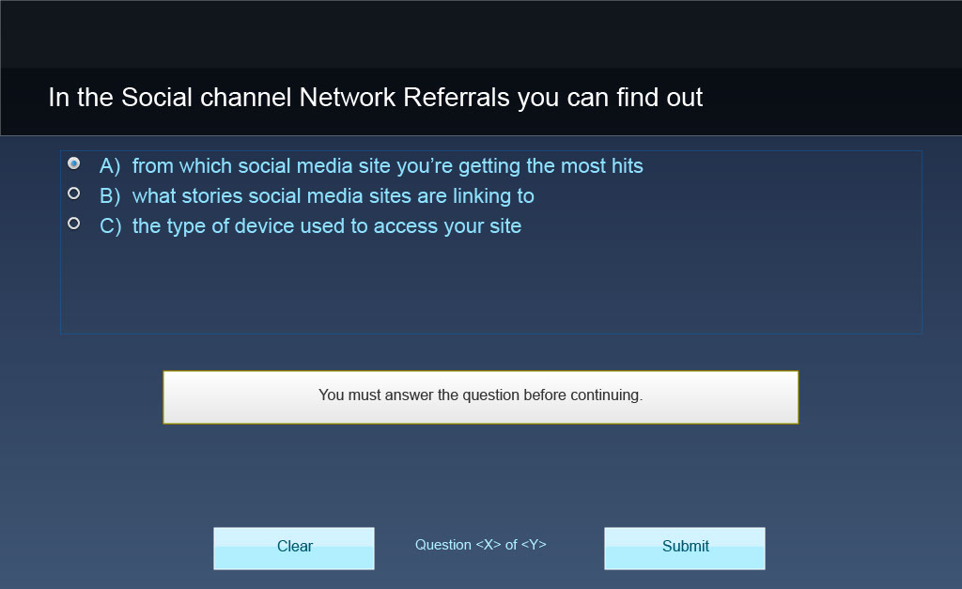
Slide notes
Text Captions

In the Social channel Network Referrals you can find out

A) from which social media site you’re getting the most hits
B) what stories social media sites are linking to
C) the type of device used to access your site

Question 13 – Multiple Choice
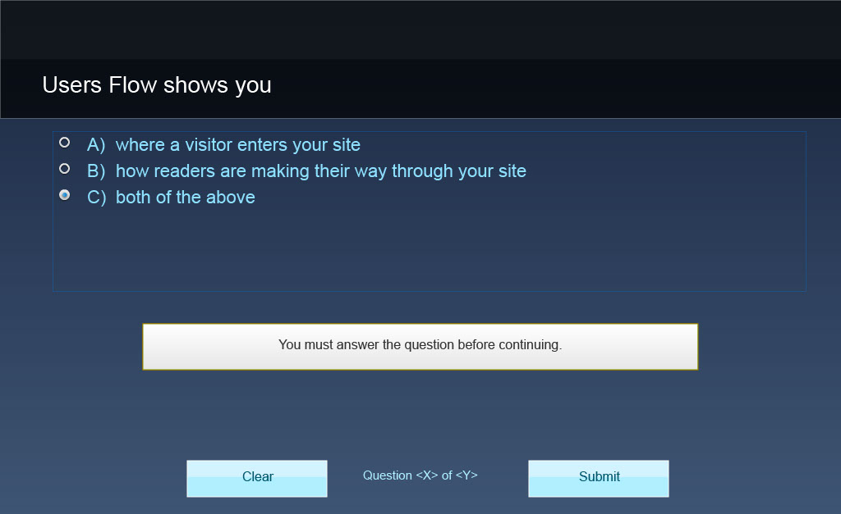
Slide notes
Text Captions

Users Flow shows you

A) where a visitor enters your site
B) how readers are making their way through your site
C) both of the above

Slide 17 - Congratulations!
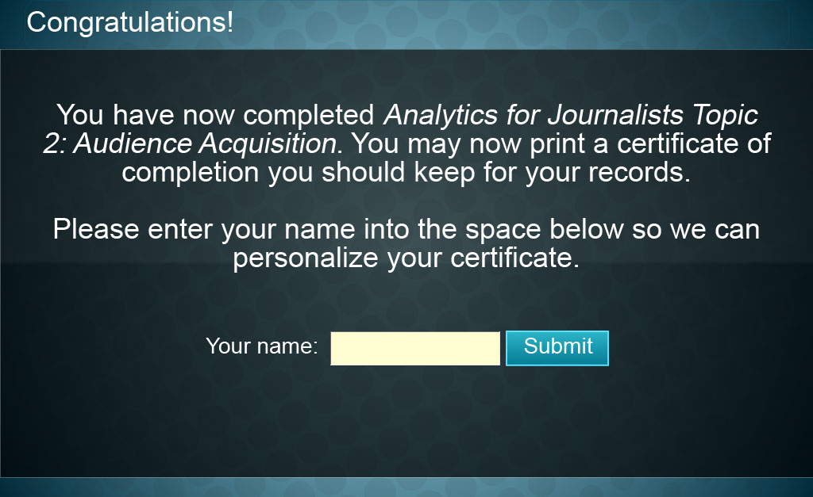
Slide notes
Text Captions

You have now completed Analytics for Journalists Topic 2: Audience Acquisition. You may now print a certificate of completion you should keep for your records.

Please enter your name into the space below so we can personalize your certificate.

Congratulations!

Slide 18 - Certificate of Completion
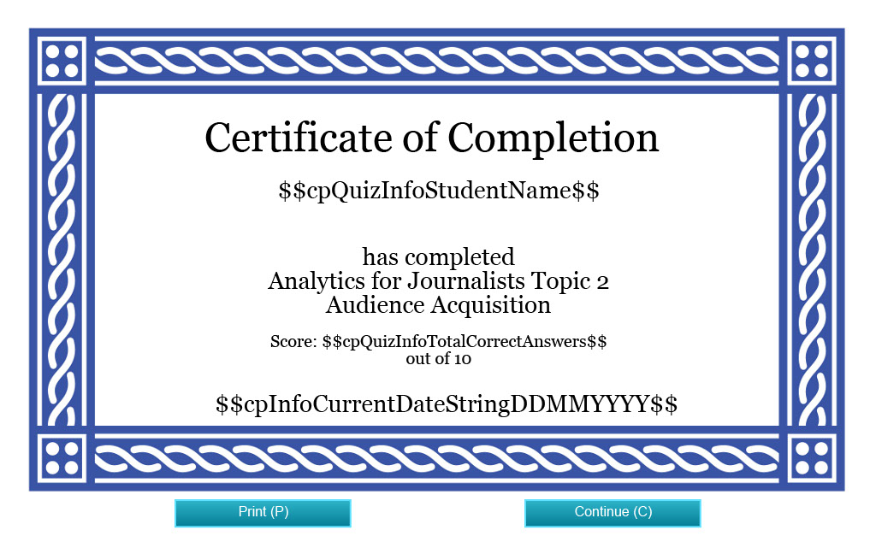
Slide notes
[Screenshot of a blank Certificate of Completion]

Slide 19 - Credits

Slide notes
Text Captions

Credits

Funding for this project was provided by the Ministry of Training, Colleges and Universities (MTCU) 2014-2015 Shared Online Course Fund.

Slide 20 - Credits

Slide notes
Text Captions

Credits

Nicole Blanchett Neheli, Professor/Journalism Coordinator Sheridan College, B.A.A. Journalism, M.A. Professional Communication
Nikolas Clarke and Gregory Prince – Sheridan College technical support
Mitchell Varley – Editor
Kyle Mackie Consulting Ltd & Park Education, Content Support
Marybeth Burriss and Vince Cifani, Instructional Designers, Digital Educational Strategies, G. Raymond Chang School of Continuing Education, Ryerson University
Nancy Walton, e-learning Support, Director, Office of e-learning, Ryerson University
Funding for this project was provided by the Ministry of Training Colleges and Universities (MTCU) 2014-2015 Shared Online Course Fund
© 2015 Nicole Blanchett Neheli, Ryerson University. Web Analytics for Journalists is made available for public use under a Creative Commons Attribution-NonCommercial-NoDerivs (CC BY-NC-ND) license.

